UNITED STATES

SECURITIES AND EXCHANGE COMMISSION
WASHINGTON, D.C. 20549

FORM 8-K

CURRENT REPORT

Pursuant to Section 13 or 15(d) of the Securities Exchange Act of 1934

Date of Report (Date of earliest event reported): January 09, 2026

MapLight Therapeutics, Inc.

(Exact name of Registrant as Specified in Its Charter)

Delaware | 001-42914 | 83-2163243
(State or Other Jurisdiction | (Commission File Number) | (IRS Employer
of Incorporation) |  | Identification No.)
800 Chesapeake Drive
Redwood City, California |  | 94063
(Address of Principal Executive Offices) |  | (Zip Code)

Registrant's Telephone Number, Including Area Code: 617 984-6300

N/A

(Former Name or Former Address, if Changed Since Last Report)

Check the appropriate box below if the Form 8-K filing is intended to simultaneously satisfy the filing obligation of the registrant under any of the following provisions:

- Written communications pursuant to Rule 425 under the Securities Act (17 CFR 230.425)

- Soliciting material pursuant to Rule 14a-12 under the Exchange Act (17 CFR 240.14a-12)

- Pre-commencement communications pursuant to Rule 14d-2(b) under the Exchange Act (17 CFR 240.14d-2(b))

- Pre-commencement communications pursuant to Rule 13e-4(c) under the Exchange Act (17 CFR 240.13e-4(c))

Securities registered pursuant to Section 12(b) of the Act:

 |  | Trading
Title of each class |  | Symbol(s) |  | Name of each exchange on which registered
Voting Common Stock, $0.0001 par value per share |  | MPLT |  | Nasdaq Global Select Market

Indicate by check mark whether the registrant is an emerging growth company as defined in Rule 405 of the Securities Act of 1933 (§ 230.405 of this chapter) or Rule 12b-2 of the Securities Exchange Act of 1934 (§ 240.12b-2 of this chapter).

Emerging growth company ☒

If an emerging growth company, indicate by check mark if the registrant has elected not to use the extended transition period for complying with any new or revised financial accounting standards provided pursuant to Section 13(a) of the Exchange Act. ☐

Item 2.02 Results of Operations and Financial Condition.

On January 9, 2026, MapLight Therapeutics, Inc. (the "Company") released the Presentation (as defined below), which includes the following selected preliminary financial information for the fiscal year ended December 31, 2025: As of December 31, 2025, the Company's cash and cash equivalents were approximately $450 million.

The cash and cash equivalents information above and in the Presentation is preliminary, has not been audited and is subject to change upon completion of the Company's financial closing procedures and the preparation of the Company's audited financial statements for the year ended December 31, 2025. Accordingly, the unaudited preliminary cash and cash equivalents balance set forth above reflects the Company's preliminary estimate with respect to such information, based on information currently available to management, and may vary from its actual financial position as of December 31, 2025. This preliminary estimate is not a comprehensive statement or estimate of the Company's financial results or financial condition as of December 31, 2025. Additional information and disclosures would be required for a more complete understanding of the Company's financial position and results of operations as of December 31, 2025. The Company's independent registered public accounting firm has not conducted an audit or review of, and does not express an opinion or any other form of assurance with respect to, this preliminary estimate. A copy of the Presentation is furnished as Exhibit 99.1 hereto.

In accordance with General Instruction B.2. of Form 8-K, the information in this Item 2.02, including Exhibit 99.1 hereto, shall not be deemed "filed" for purposes of Section 18 of the Securities Exchange Act of 1934, as amended (the "Exchange Act"), or otherwise subject to the liability of that section, nor shall it be deemed incorporated by reference in any of the Company's filings under the Securities Act of 1933, as amended (the "Securities Act"), or the Exchange Act, whether made before or after the date hereof, regardless of any incorporation language in such a filing, except as expressly set forth by specific reference in such a filing.

Item 7.01 Regulation FD Disclosure.

On January 9, 2026, the Company issued a press release announcing an update to its timing expectations for the disclosure of topline results from its ongoing Phase 2 ZEPHYR and IRIS clinical trials, which are now expected in the third quarter of 2026. A copy of this press release is furnished as Exhibit 99.2 to this Current Report on Form 8-K.

On January 9, 2026, the Company updated its corporate presentation for use in meetings with investors, analysts and others (the "Presentation"). The Presentation is available on the Company's website and a copy is furnished as Exhibit 99.1 to this Current Report on Form 8-K.

In accordance with General Instruction B.2. of Form 8-K, the information in this Item 7.01, including Exhibit 99.1 and Exhibit 99.2 hereto, shall not be deemed "filed" for purposes of Section 18 of the Exchange Act or otherwise subject to the liability of that section, nor shall it be deemed incorporated by reference in any of the Company's filings under the Securities Act or the Exchange Act, whether made before or after the date hereof, regardless of any incorporation language in such a filing, except as expressly set forth by specific reference in such a filing.

Item 9.01 Financial Statements and Exhibits.

(d) Exhibits

 | Exhibit |  |  |  | Description
 | Number |  |  |  | Description
 | 99.1 |  | Corporate Presentation, dated January 9, 2026
99.2 |  |  | Press Release, dated January 9, 2026
104 |  |  | Cover Page Interactive Data File (formatted as inline XBRL).

SIGNATURES

Pursuant to the requirements of the Securities Exchange Act of 1934, the registrant has duly caused this report to be signed on its behalf by the undersigned hereunto duly authorized.

MapLight Therapeutics, Inc.

Date: January 9, 2026 By: /s/ Christopher Kroeger

Christopher A. Kroeger, M.D.

Chief Executive Officer



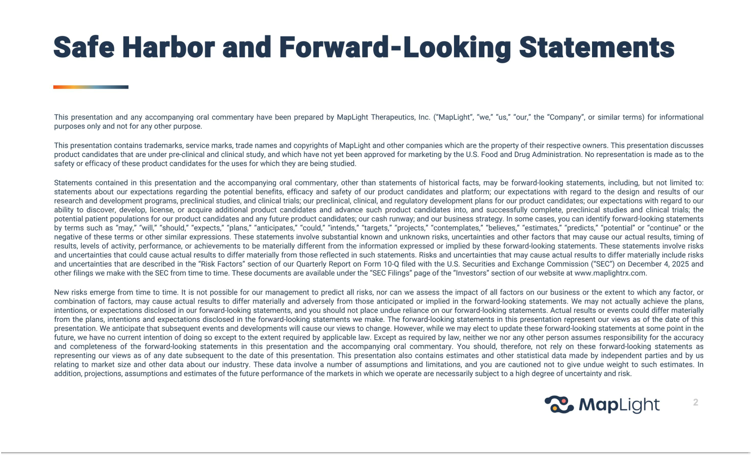

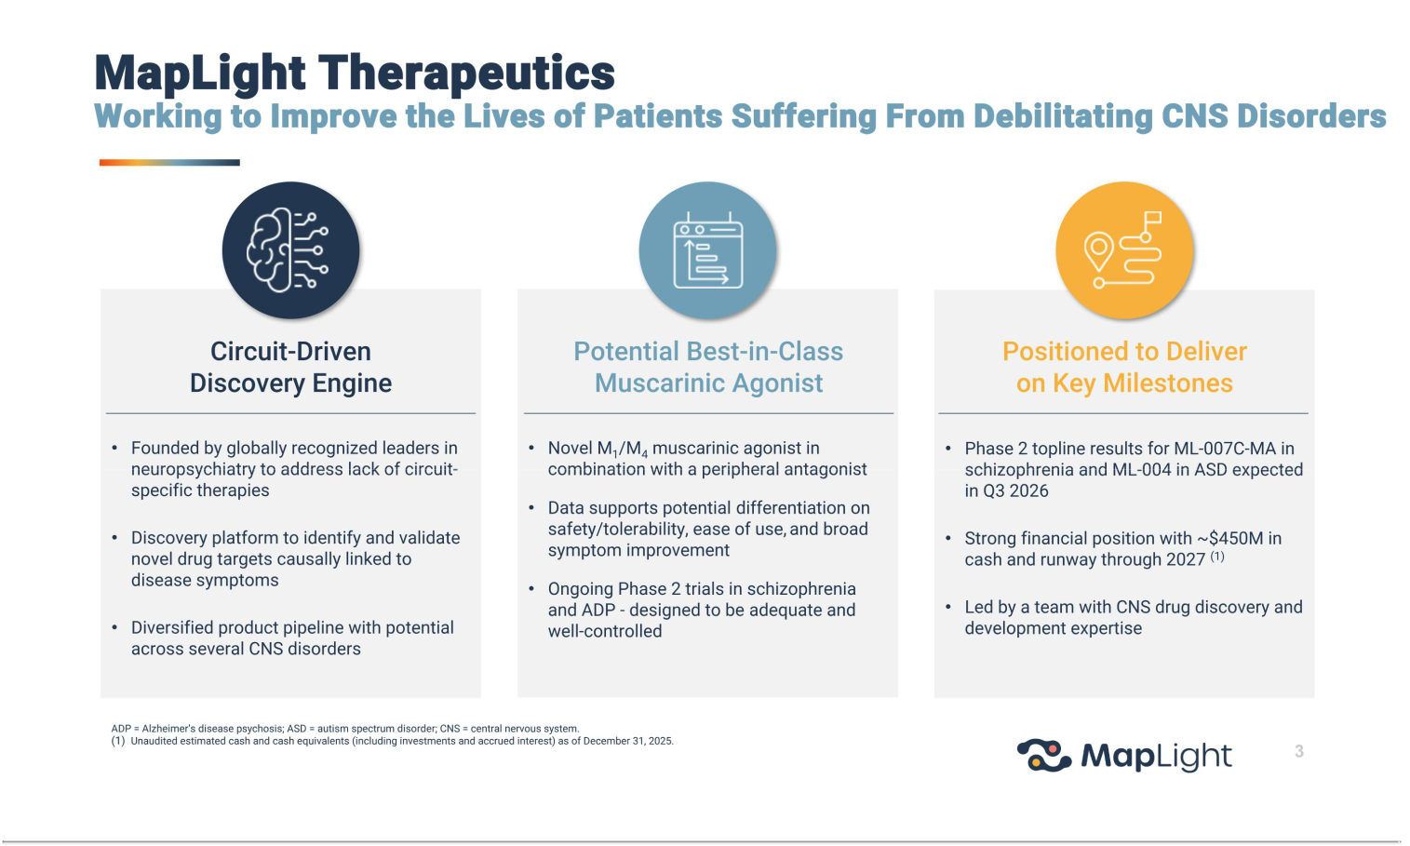

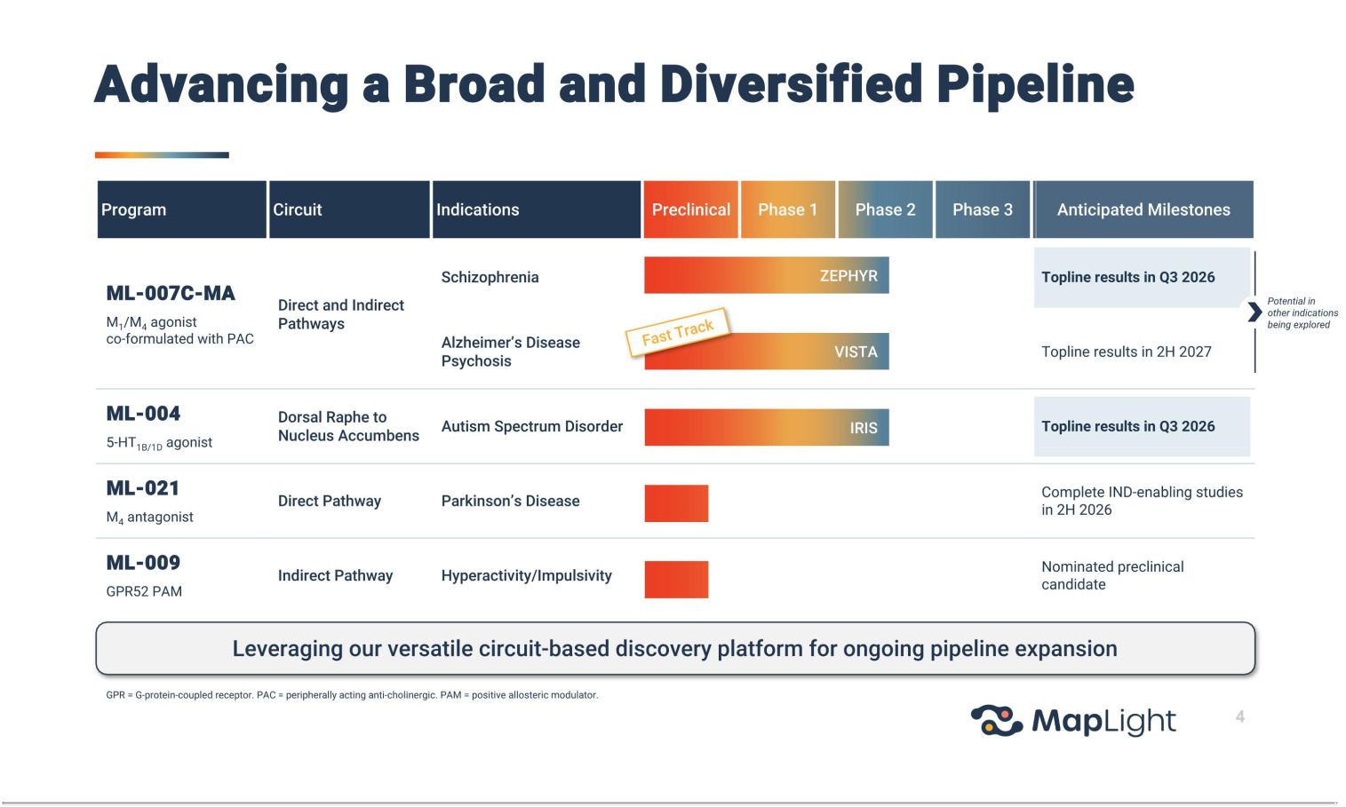



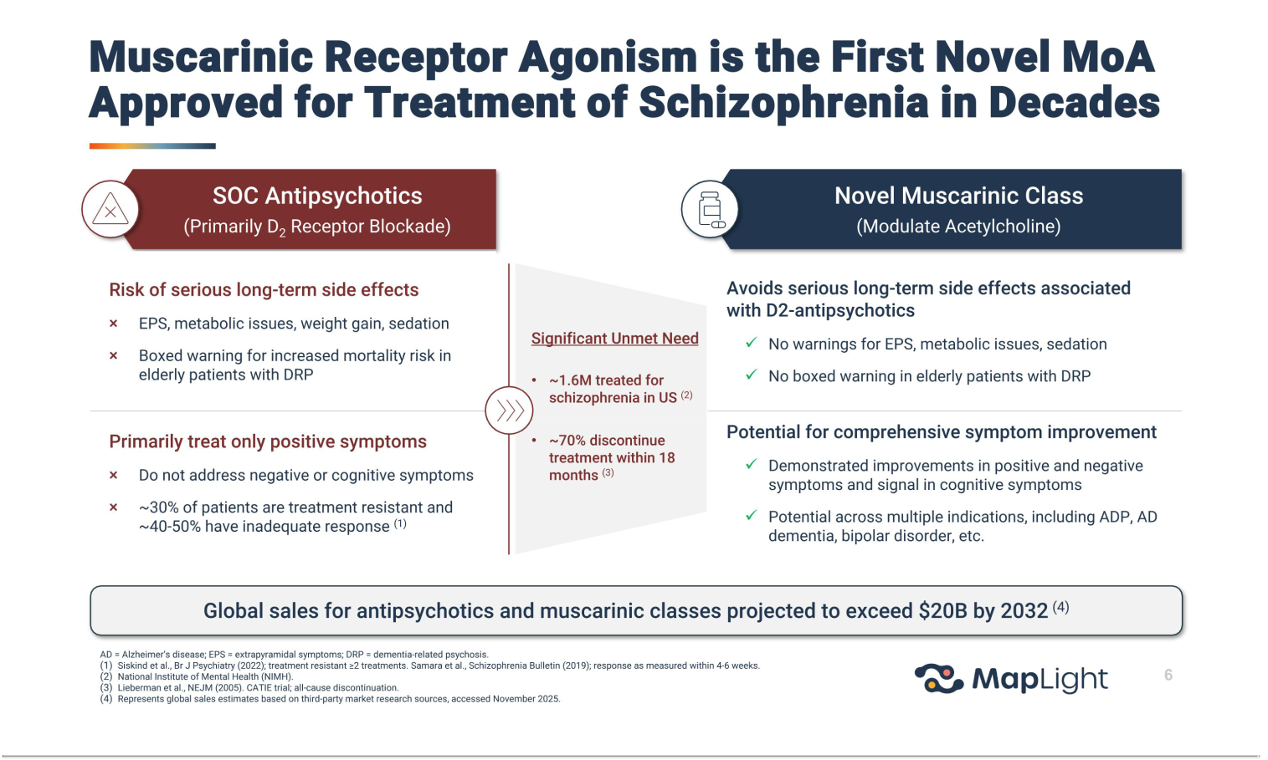

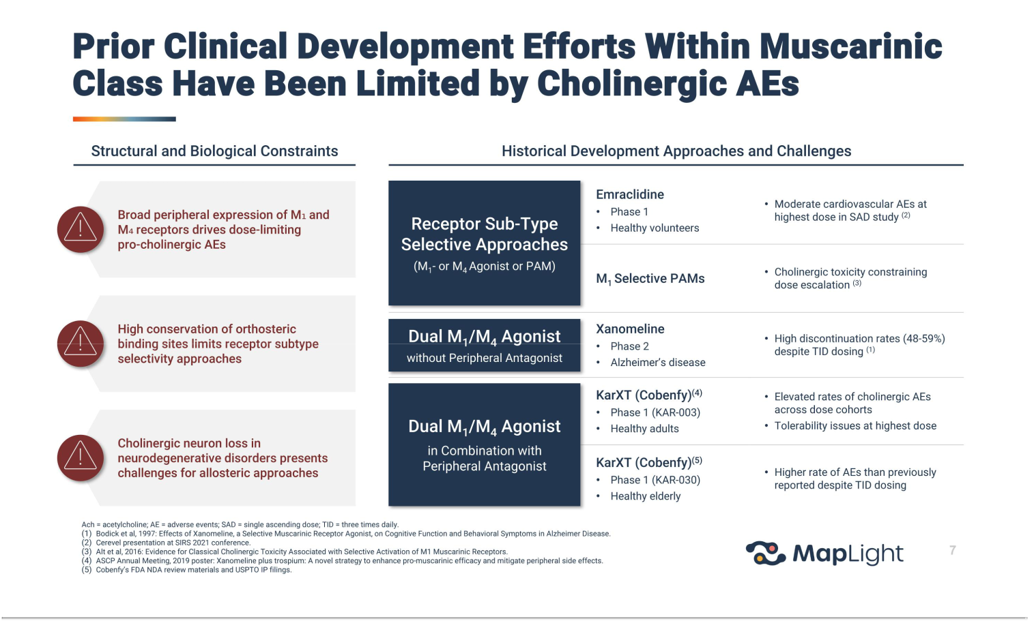

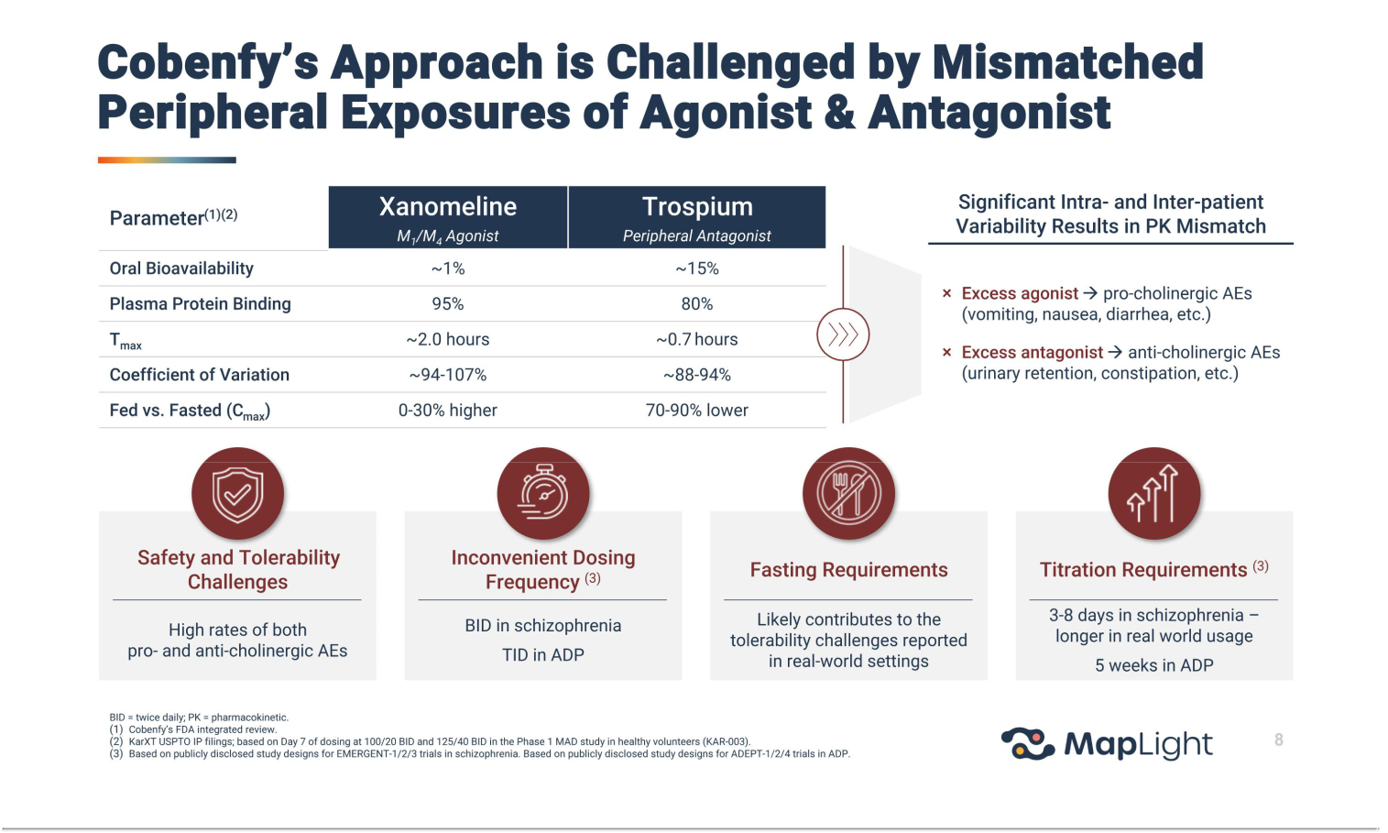

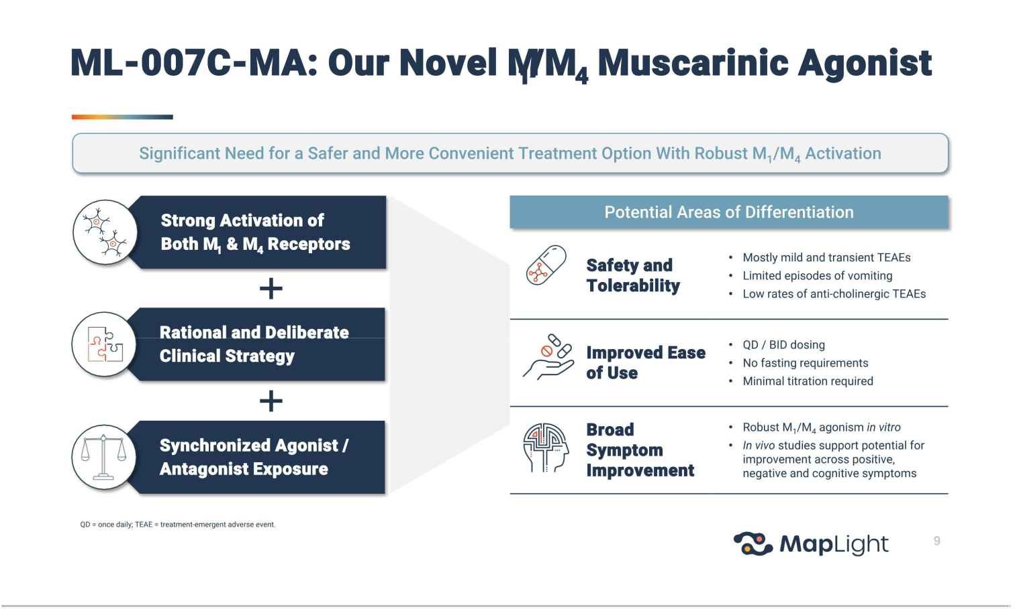

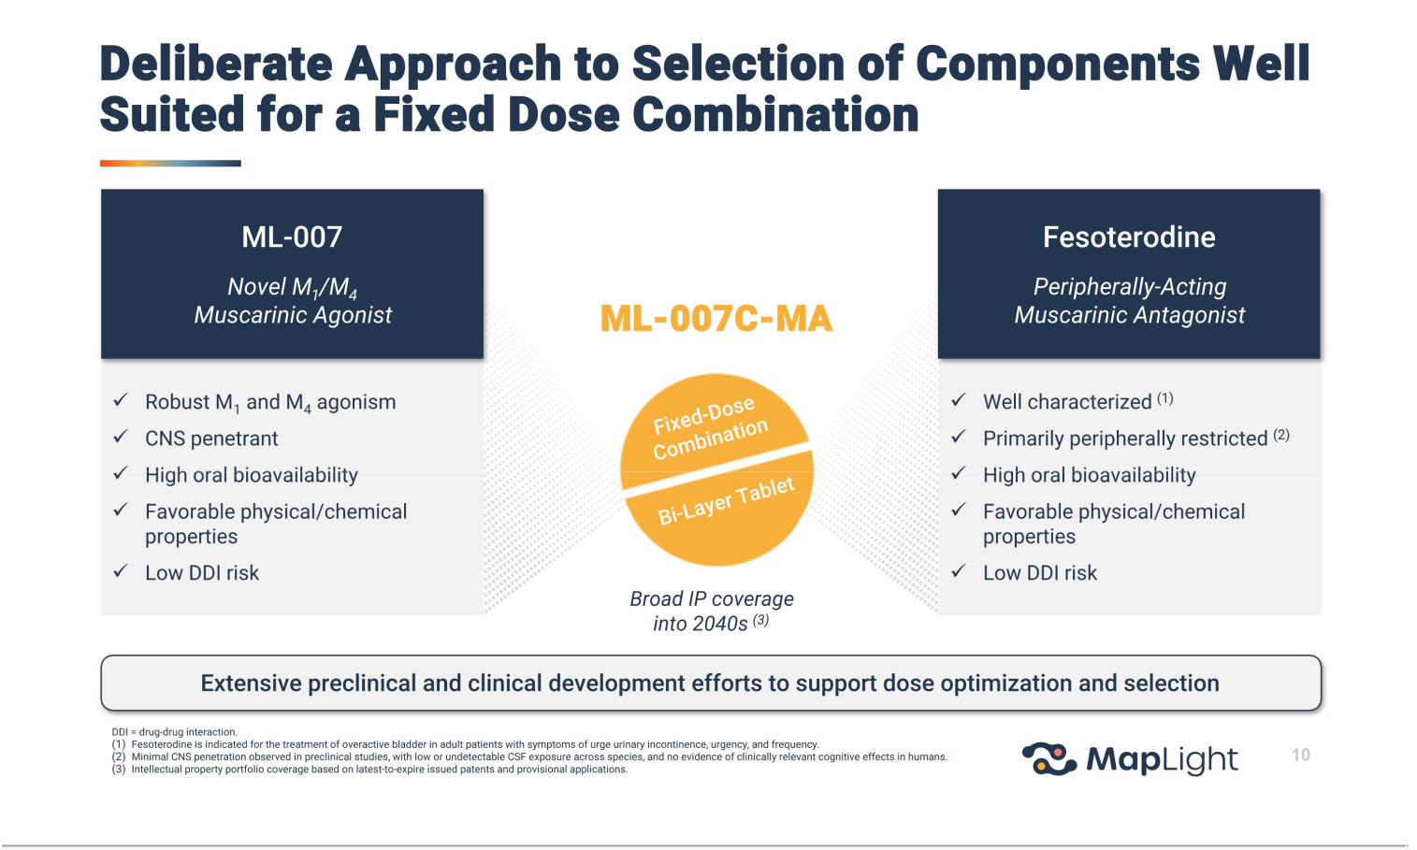

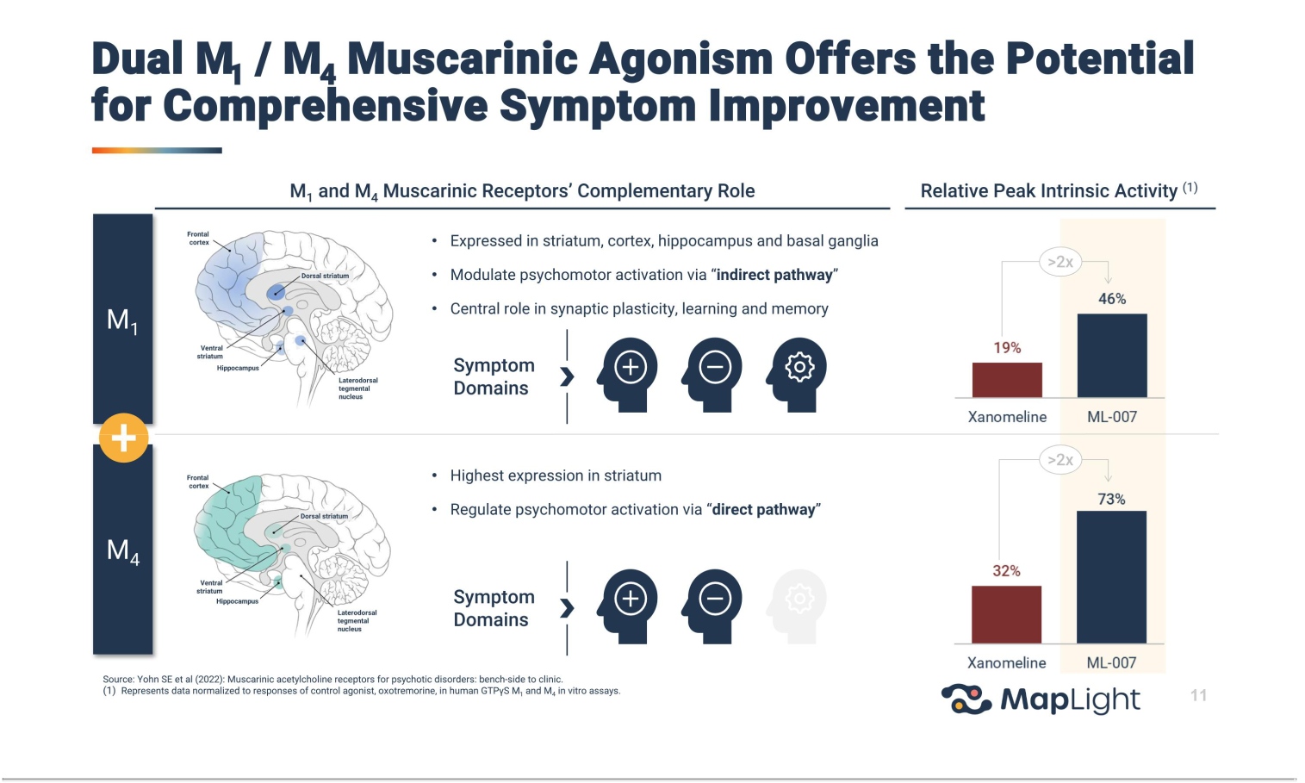

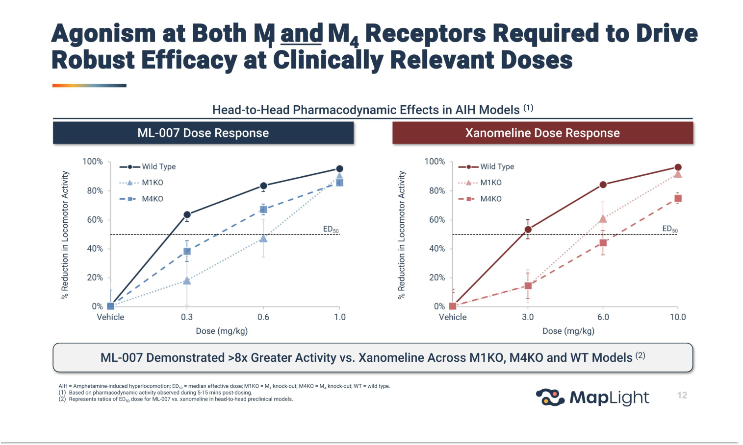

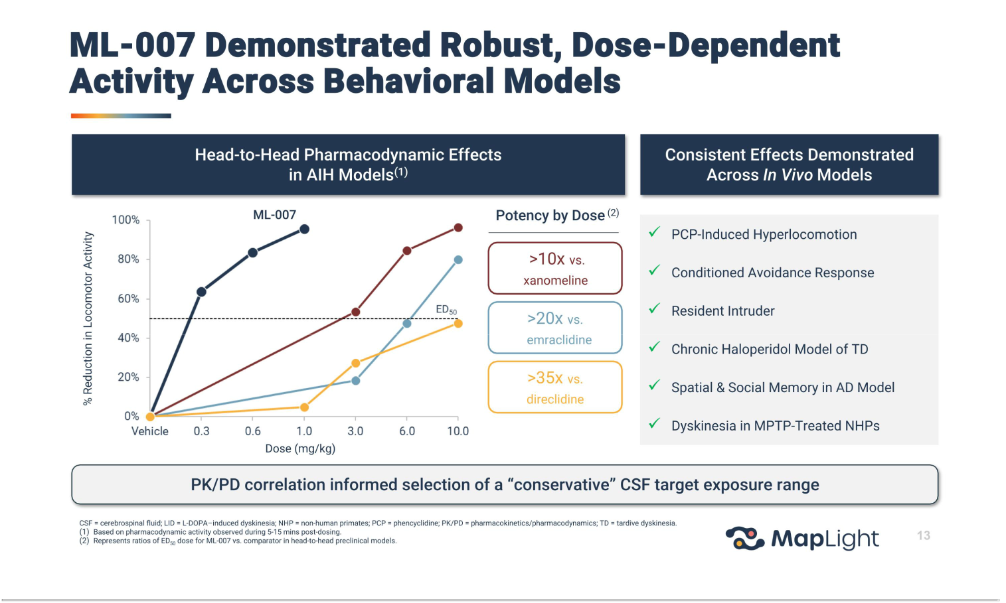

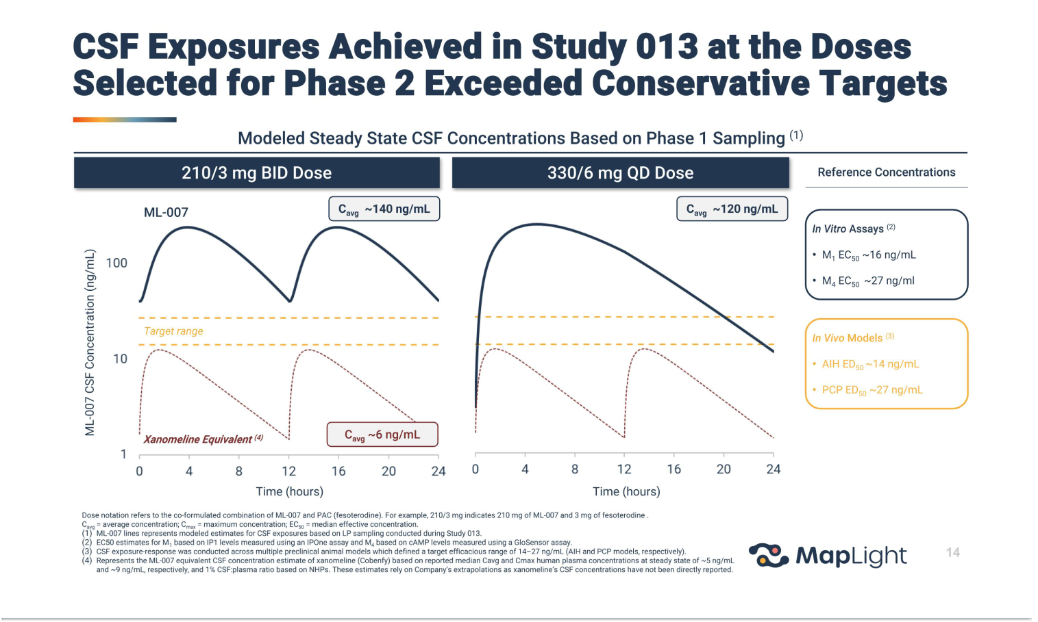

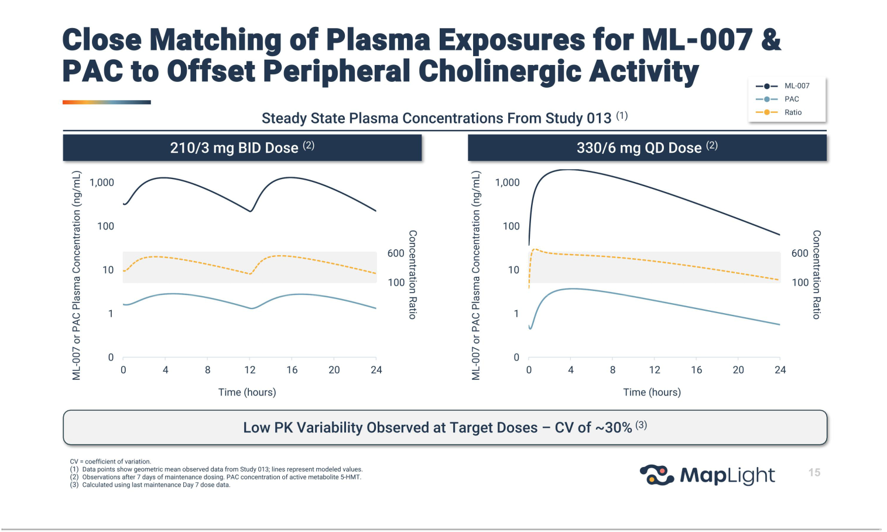

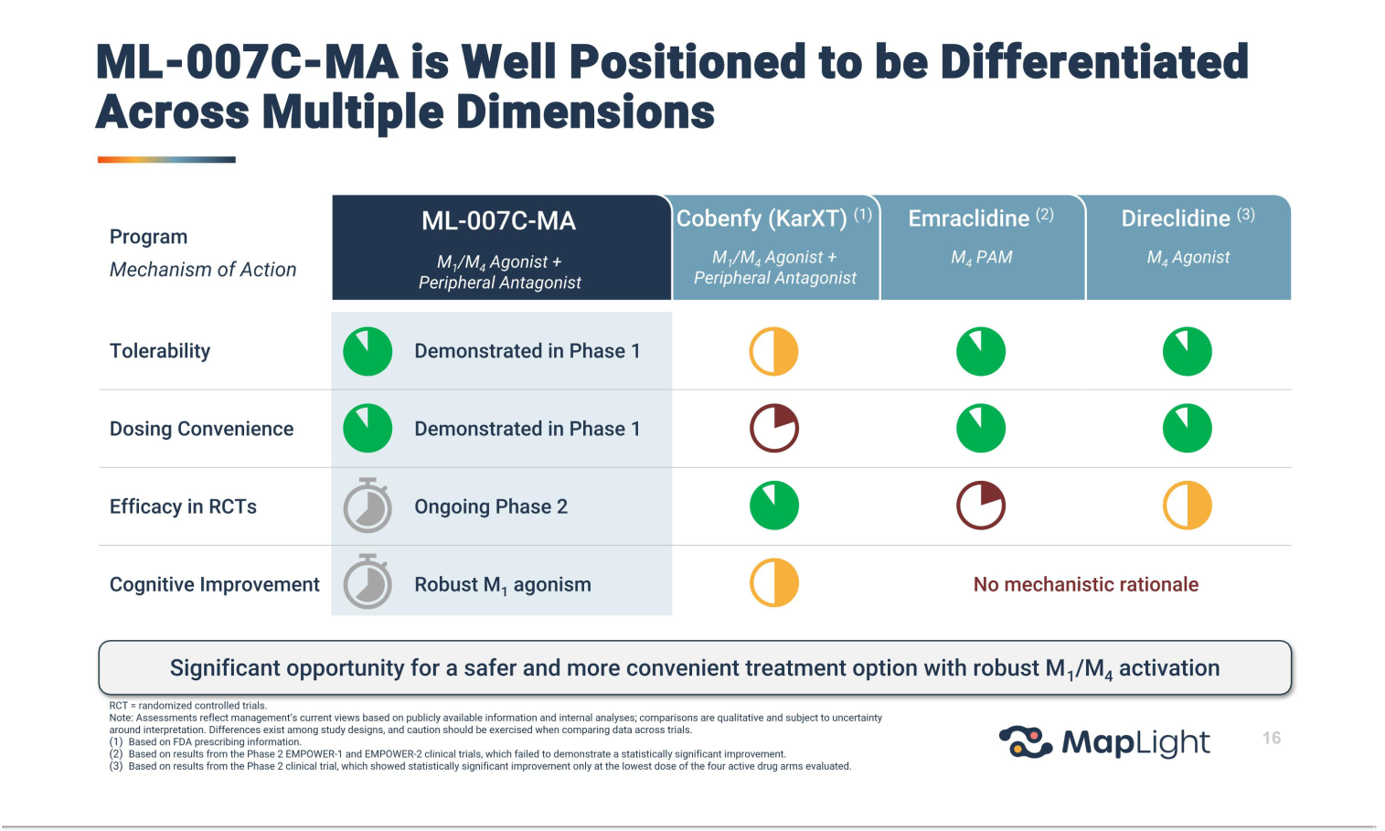

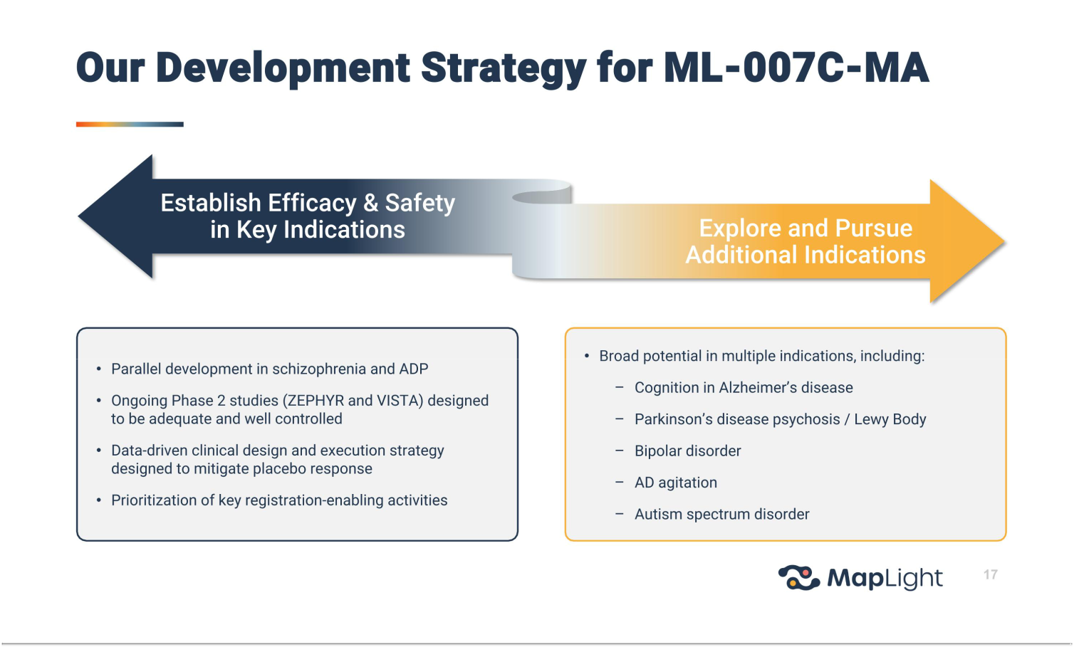



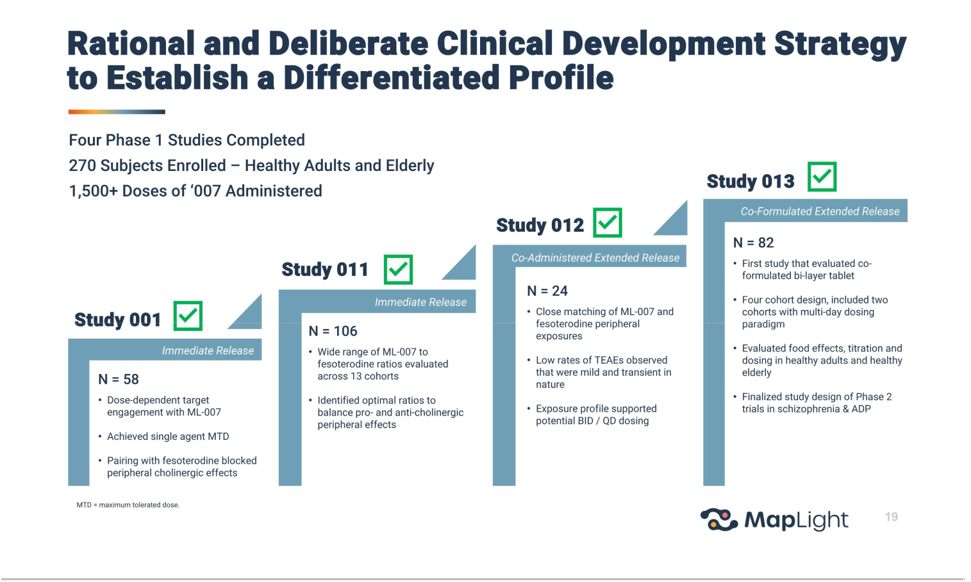

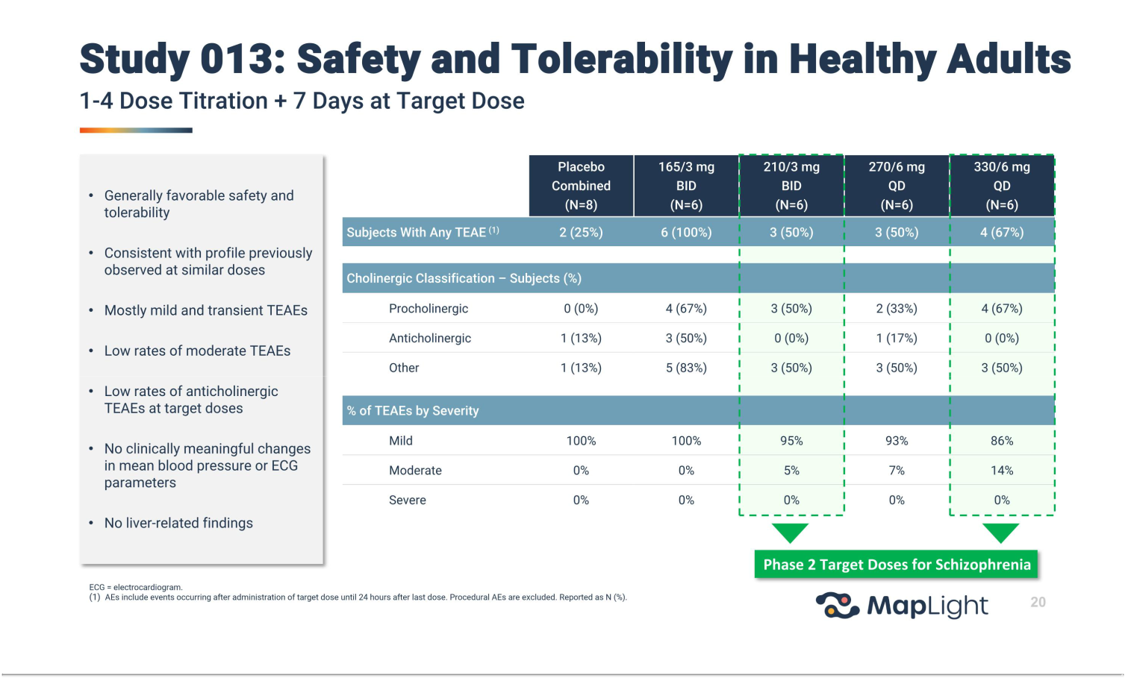

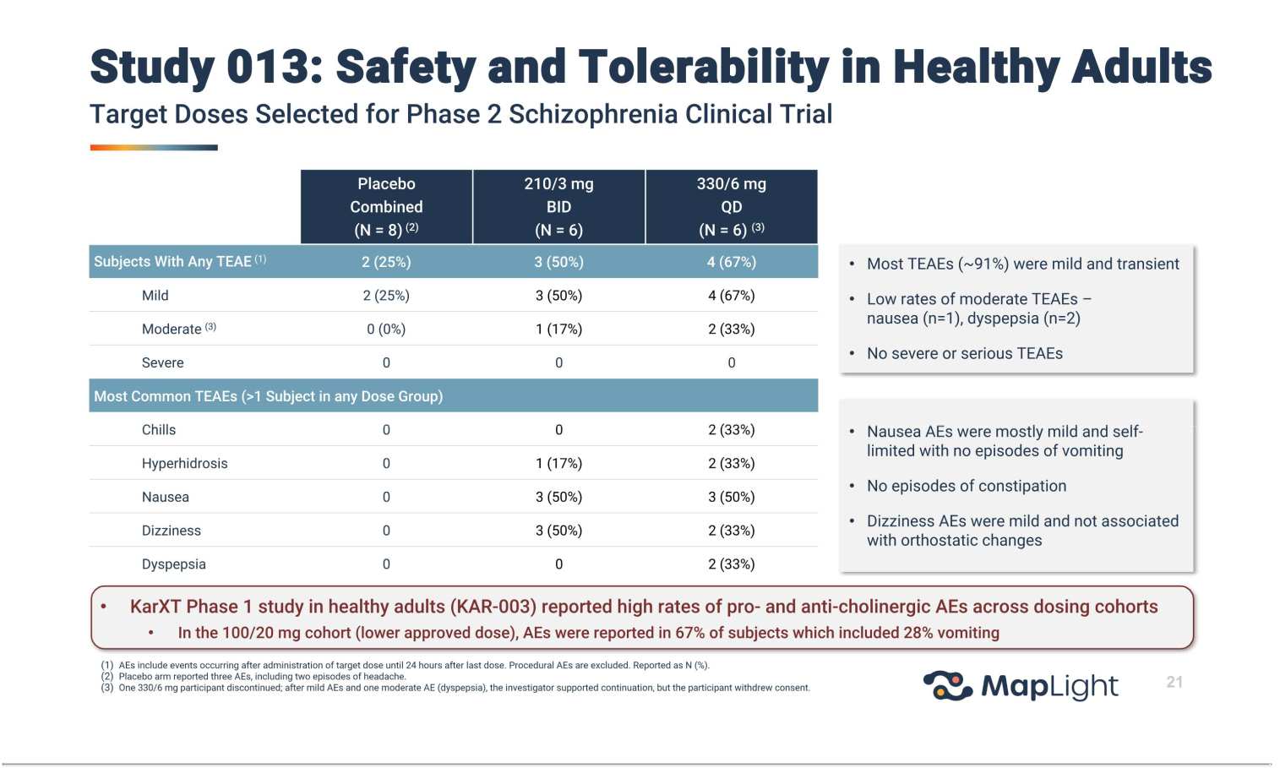

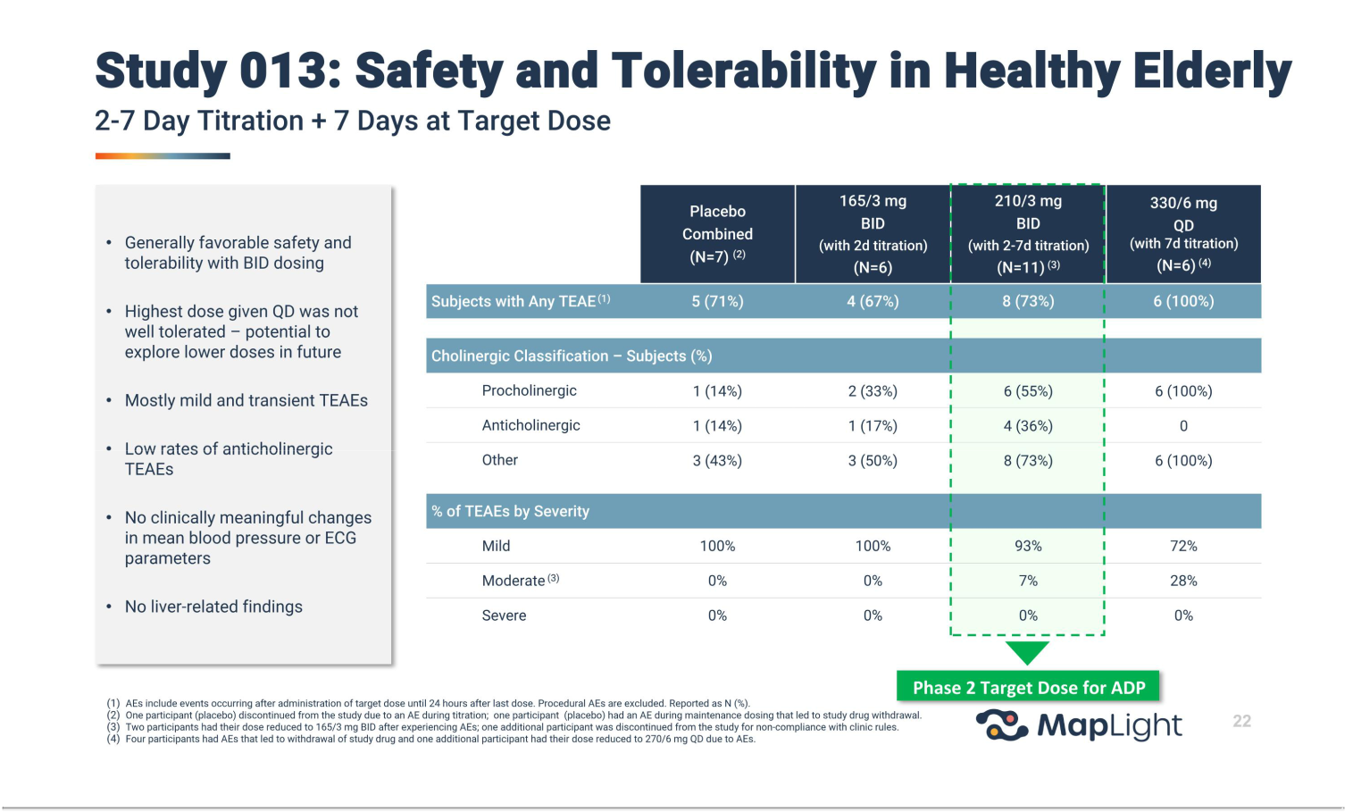

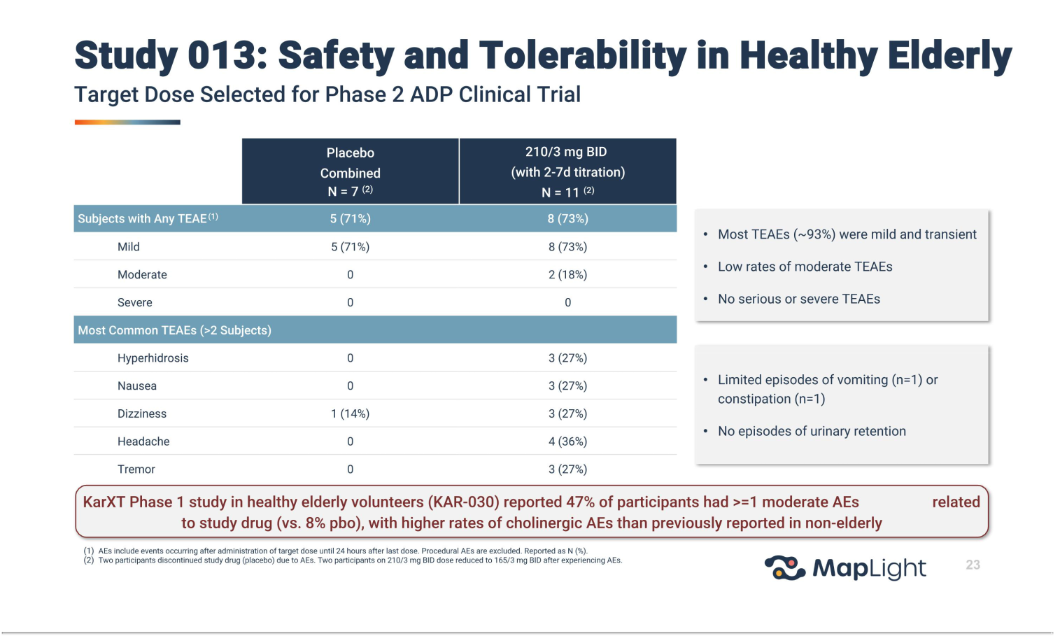



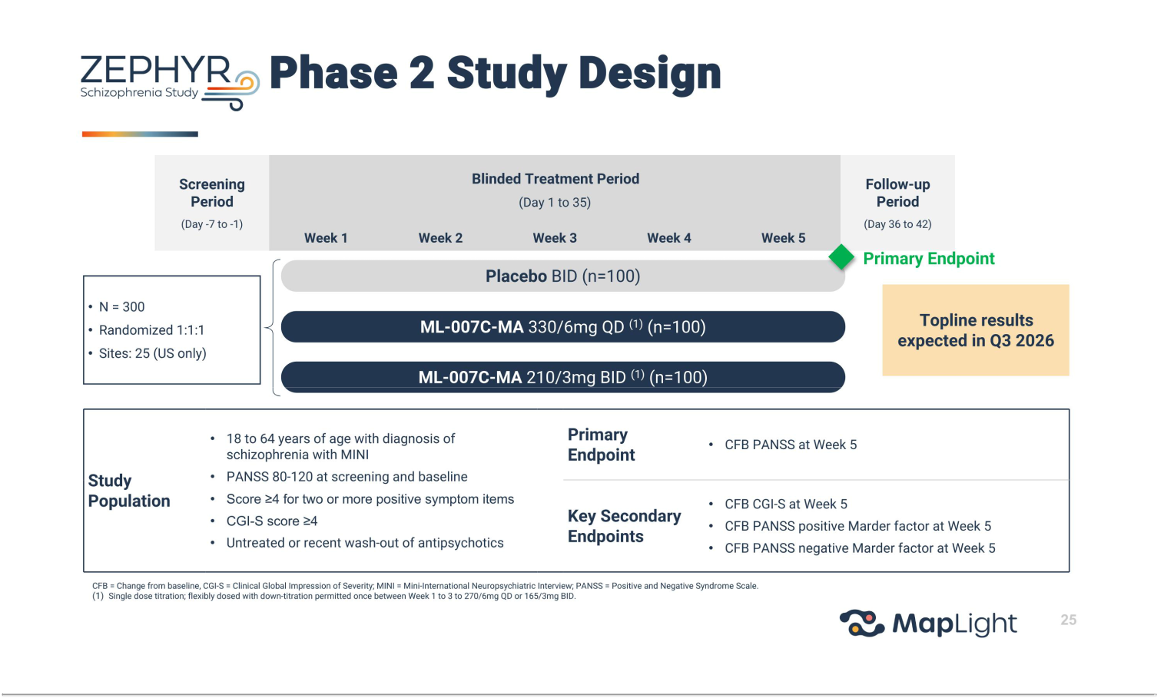

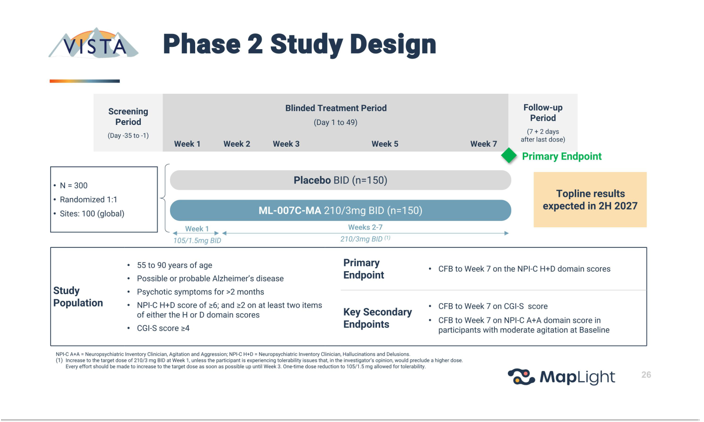

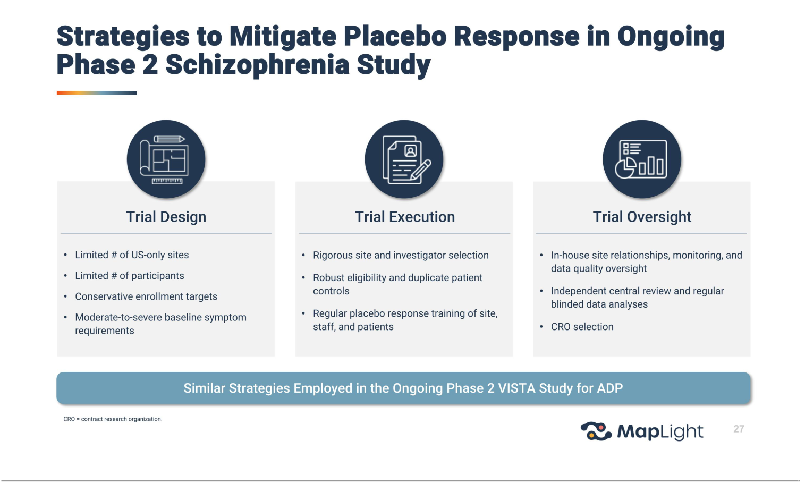

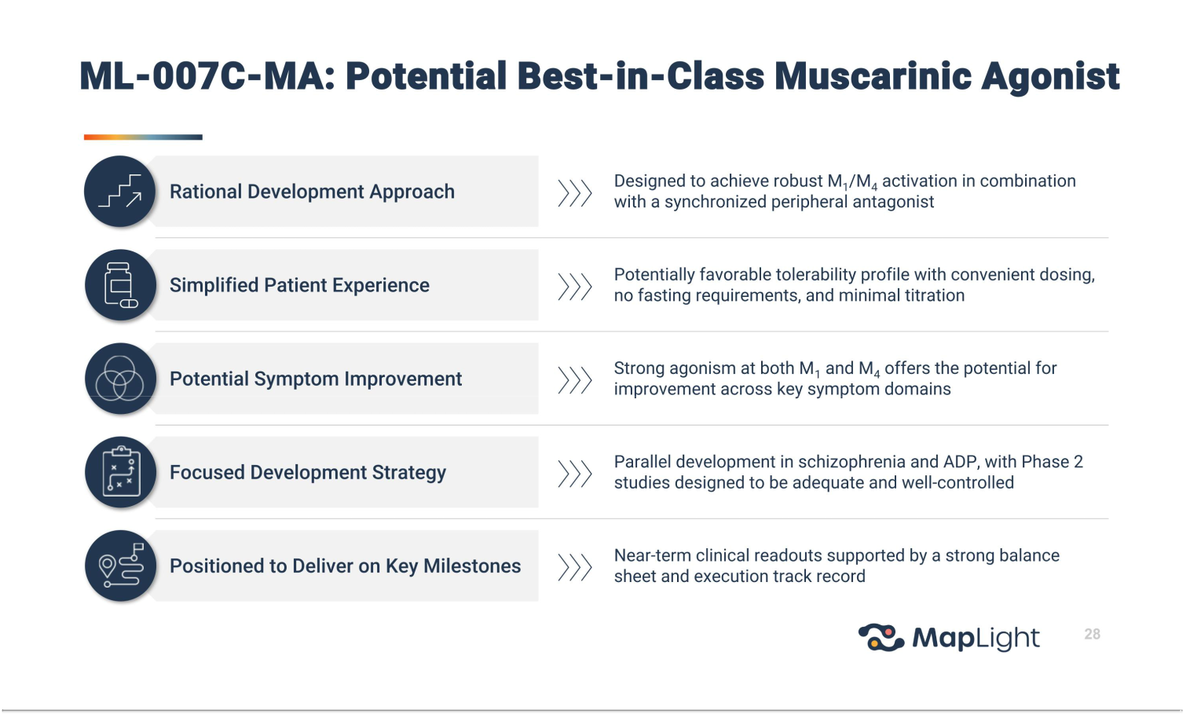



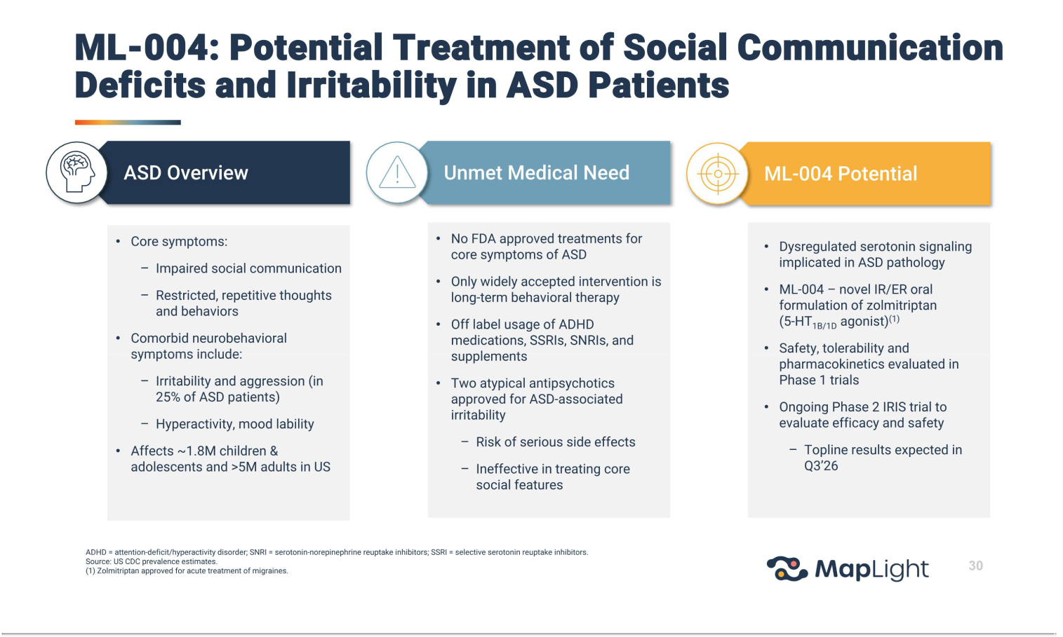

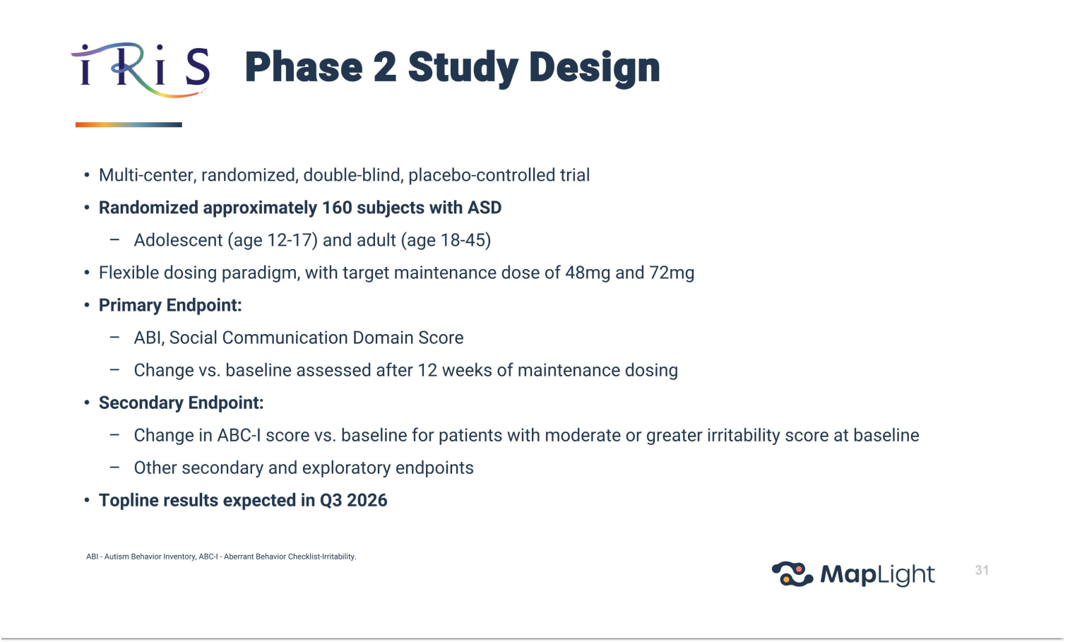

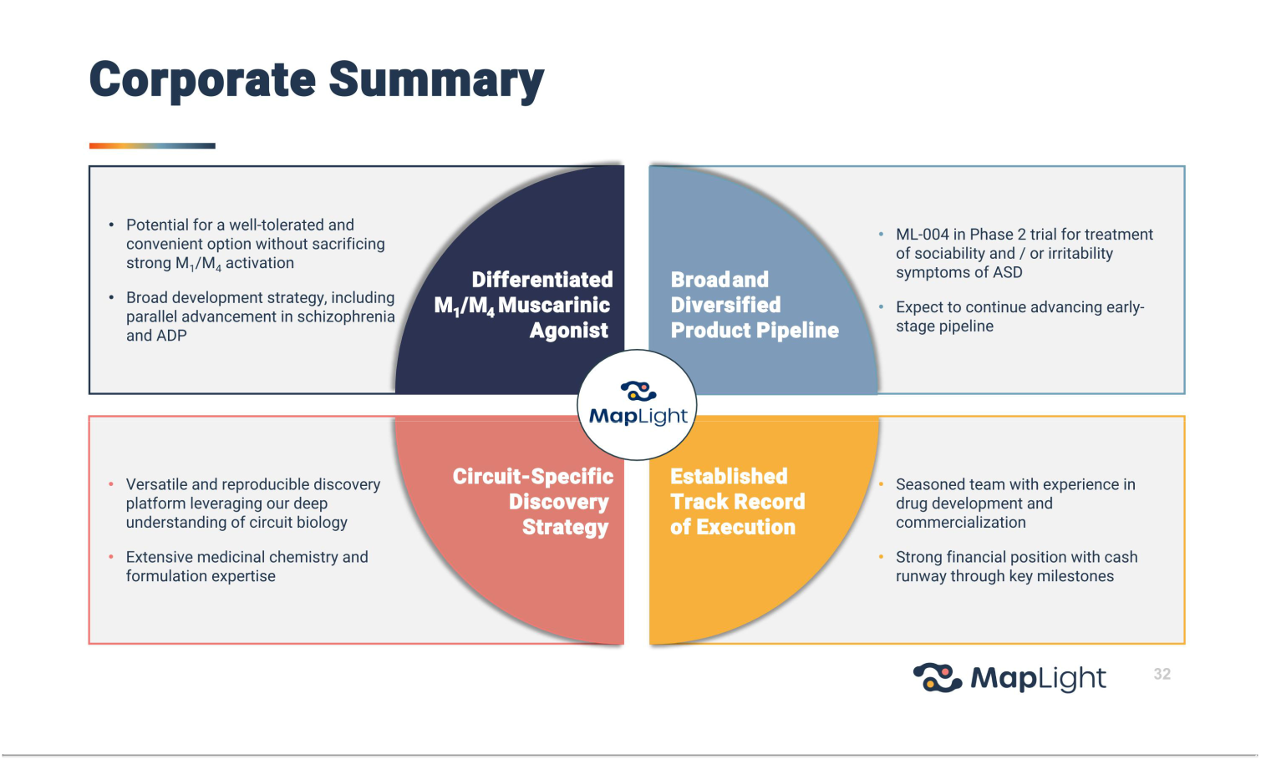



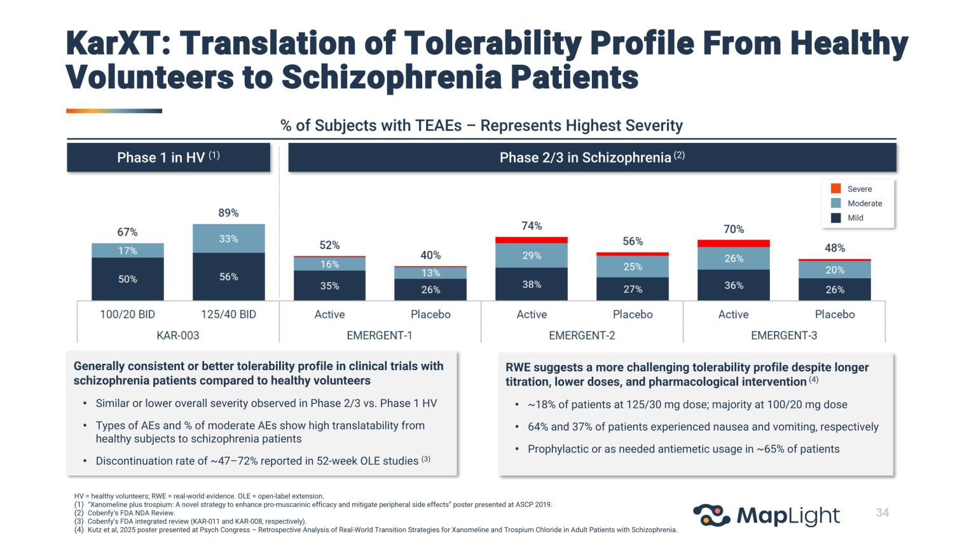

Exhibit 99.2

MapLight Therapeutics Updates Expected Timing of Topline Results for Ongoing Phase 2 Studies to Q3 2026

SAN FRANCISCO and BOSTON, Jan. 9, 2026 (GLOBE NEWSWIRE) -- MapLight Therapeutics, Inc. (MapLight) (Nasdaq: MPLT) today announced an update to the expected timing of topline results for its ongoing Phase 2 ZEPHYR and IRIS clinical studies, which are progressing ahead of schedule.

The company’s Phase 2 ZEPHYR trial evaluating ML-007C-MA for the treatment of schizophrenia continues to enroll robustly, and topline results are now expected in the third quarter of 2026. The ZEPHYR study is a randomized, double-blind, placebo-controlled trial that is expected to enroll 300 hospitalized adult participants with schizophrenia experiencing acute exacerbation of psychosis.

“The accelerated enrollment pace in the ZEPHYR trial allows us to narrow our timing guidance to the third quarter of 2026,” said Chris Kroeger, co-Founder and Chief Executive Officer of MapLight. “This momentum is testimony to our disciplined execution and commitment to advancing our programs efficiently while maintaining the highest quality standards.”

In addition, following completion of enrollment in the Phase 2 IRIS trial for ML-004 in autism spectrum disorder, topline results for that study are now expected in the third quarter of 2026. The IRIS study is a double-blind, placebo-controlled trial that randomized approximately 160 adult and adolescent participants.

About MapLight Therapeutics

MapLight Therapeutics is a clinical-stage biopharmaceutical company focused on improving the lives of patients suffering from debilitating central nervous system disorders. The company was founded by globally recognized leaders in psychiatry and neuroscience research to address the lack of circuit-specific pharmacotherapies available for patients. The company’s discovery platform holds the potential to fill this void by identifying neural circuits causally linked to disease and targeting those circuits for therapeutic modulation.

For more information, please visit www.maplightrx.com.

Forward Looking Statements

Certain statements in this press release may constitute “forward-looking statements” within the meaning of the federal securities laws, including the company’s expectations regarding the potential benefits of its current and future product candidates and programs, plans for its current and future clinical trials, the anticipated timing of results from the company’s Phase 2 ZEPHYR and IRIS clinical trials and enrollment in the ZEPHYR trial. Words such as “may,” “might,” “will,” “objective,” “intend,” “should,” “could,” “can,”

“would,” “expect,” “believe,” “design,” “estimate,” “predict,” “potential,” “develop,” “plan” or the negative of these terms, and similar expressions, are intended to identify forward-looking statements. While the company believes these forward-looking statements are reasonable, undue reliance should not be placed on any such forward-looking statements, which are based on information available to the company on the date of this release. These forward-looking statements are based upon current estimates and assumptions and are subject to various risks and uncertainties (including, without limitation, those set forth in the company’s filings with the U.S. Securities and Exchange Commission (SEC)), many of which are beyond the company’s control and subject to change. Actual results could be materially different. Risks and uncertainties include: global macroeconomic conditions and related volatility; expectations regarding the initiation, progress, and expected results of the company’s preclinical studies, clinical trials and research and development programs; the unpredictable relationship between preclinical study results and clinical study results; the risk that results obtained in any clinical trials to date may not be indicative of results obtained in ongoing or future trials; the timing or likelihood of regulatory filings and approvals; expectations regarding the company’s ability to fund its current operations; and other risks and uncertainties identified in the company’s Quarterly Report on Form 10-Q filed with the SEC on December 4, 2025, and subsequent disclosure documents the company may file with the SEC. The company claims the protection of the safe harbor contained in the Private Securities Litigation Reform Act of 1995 for forward-looking statements. The company expressly disclaims any obligation to update or alter any statements whether as a result of new information, future events or otherwise, except as required by law.

For investor inquiries: investors@maplightrx.com

For media inquiries: media@maplightrx.com

