UNITED STATES

SECURITIES AND EXCHANGE COMMISSION
Washington, D.C. 20549

FORM 8-K

CURRENT REPORT

Pursuant to Section 13 or 15(d)
of the Securities Exchange Act of 1934

Date of Report (Date of earliest event reported): June 22, 2026

MapLight Therapeutics, Inc.

(Exact name of registrant as specified in its charter)

Delaware | 001-42914 | 83-2163243
(State or other jurisdiction | (Commission | (IRS Employer
of incorporation) | File Number) | Identification No.)

800 Chesapeake Drive

Redwood City, California 94063
(Address of principal executive offices)

Registrant’s telephone number, including area code: (617) 984-6300

N/A

(Former name or former address, if changed since last report.)

Check the appropriate box below if the Form 8-K filing is intended to simultaneously satisfy the filing obligation of the registrant under any of the following provisions:

- Written communications pursuant to Rule 425 under the Securities Act (17 CFR 230.425)

- Soliciting material pursuant to Rule 14a-12 under the Exchange Act (17 CFR 240.14a-12)

- Pre-commencement communications pursuant to Rule 14d-2(b) under the Exchange Act (17 CFR 240.14d-2(b))

- Pre-commencement communications pursuant to Rule 13e-4(c) under the Exchange Act (17 CFR 240.13e-4(c))

Securities registered pursuant to Section 12(b) of the Act:

Title of each class |  | Trading |  | Name of each exchange
 |  | symbol(s) |  | on which registered
Voting Common Stock, $0.0001 par value per share |  | MPLT |  | Nasdaq Global Select Market

Indicate by check mark whether the registrant is an emerging growth company as defined in as defined in Rule 405 of the Securities Act of 1933 (§230.405 of this chapter) or Rule 12b-2 of the Securities Exchange Act of 1934 (§240.12b-2 of this chapter).

Emerging growth company ☒

If an emerging growth company, indicate by check mark if the registrant has elected not to use the extended transition period for complying with any new or revised financial accounting standards provided pursuant to Section 13(a) of the Exchange Act. ☐

Item 7.01 Regulation FD Disclosure.

On June 22, 2026, MapLight Therapeutics, Inc. (the “Company”) will hold a conference call to discuss the topline results from IRIS (ML-004-002), a Phase 2 study of ML-004 in autism spectrum disorder (the “IRIS Trial Results”). A copy of the presentation that will accompany the conference call is furnished herewith as Exhibit 99.1 to this Current Report on Form 8-K.

In accordance with General Instruction B.2. of Form 8-K, the information in this Item 7.01 and Exhibit 99.1 hereto shall not be deemed “filed” for purposes of Section 18 of the Securities Exchange Act of 1934, as amended (the “Exchange Act”), or otherwise subject to the liability of that section, nor shall it be deemed incorporated by reference in any of the Company’s filings under the Securities Act of 1933, as amended, or under the Exchange Act, whether made before or after the date hereof, regardless of any incorporation language in such a filing, except as expressly set forth by specific reference in such a filing.

Item 8.01 Other Events.

On June 22, 2026, the Company issued a press release announcing the IRIS Trial Results. A copy of this press release is filed as Exhibit 99.2 to this Current Report on Form 8-K and is incorporated herein by reference.

Item 9.01 Financial Statements and Exhibits.

(d) Exhibits

Exhibit |  | Exhibit Description
Number
99.1 |  | Company Presentation, dated June 22, 2026.
99.2 |  | Press Release, dated June 22, 2026.
104 |  | Cover Page Interactive Data File (formatted as inline XBRL).

SIGNATURES

Pursuant to the requirements of the Securities Exchange Act of 1934, the registrant has duly caused this report to be signed on its behalf by the undersigned hereunto duly authorized.

MapLight Therapeutics, Inc.

Dated: June 22, 2026 By: /s/ Christopher A. Kroeger

Christopher A. Kroeger, M.D.

Chief Executive Officer

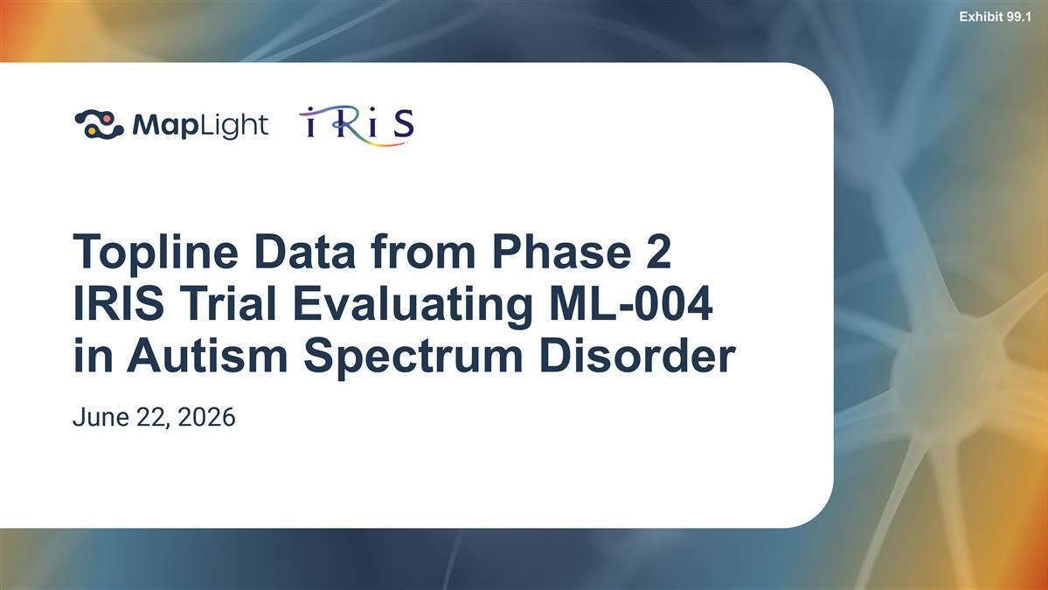

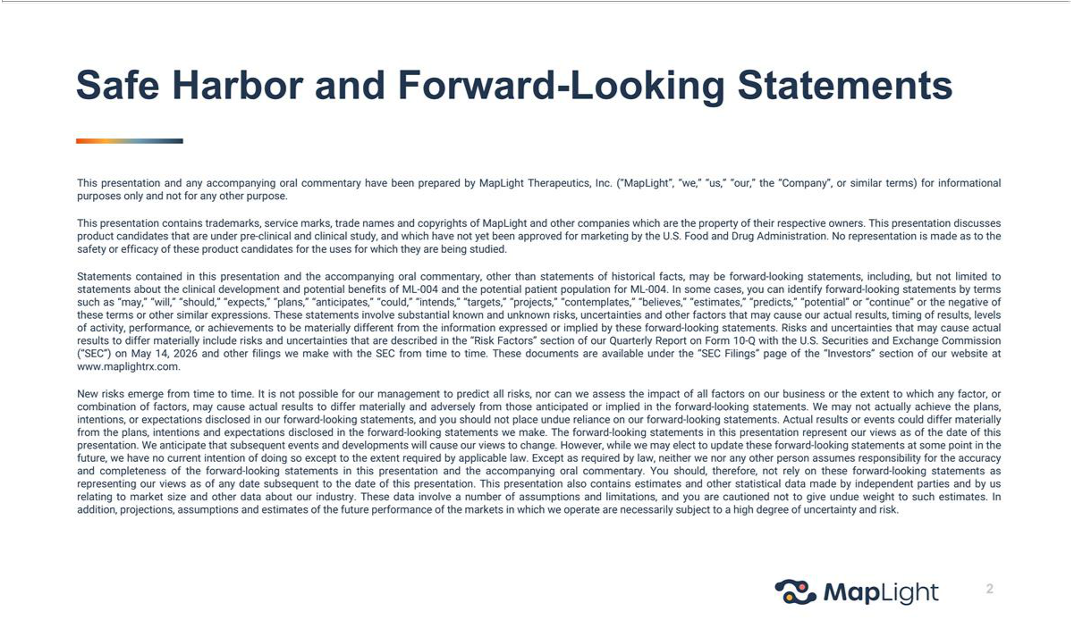

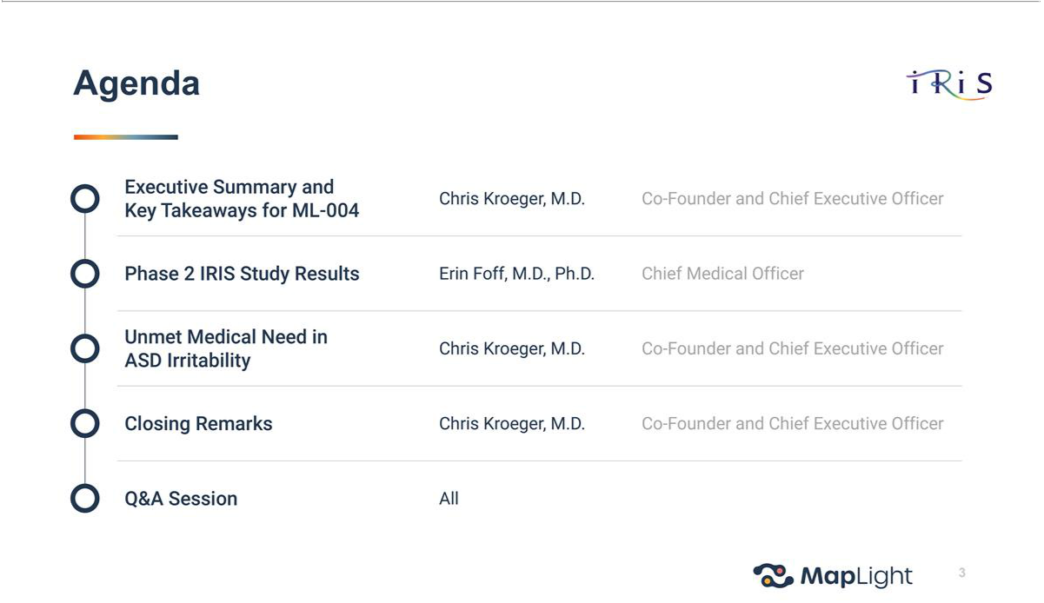

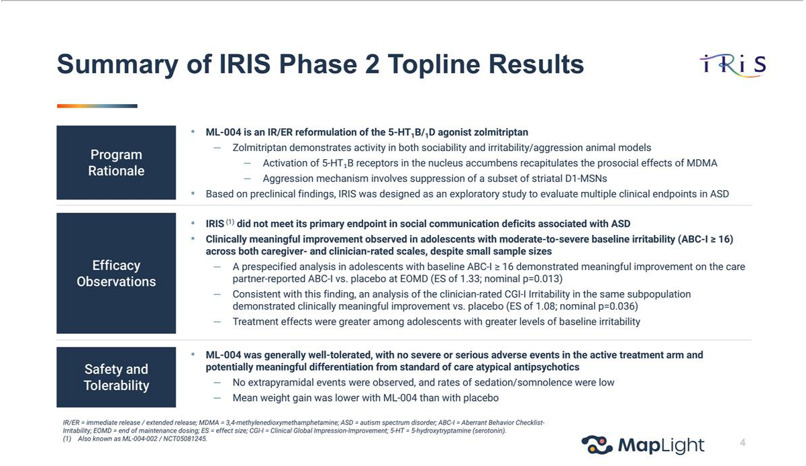

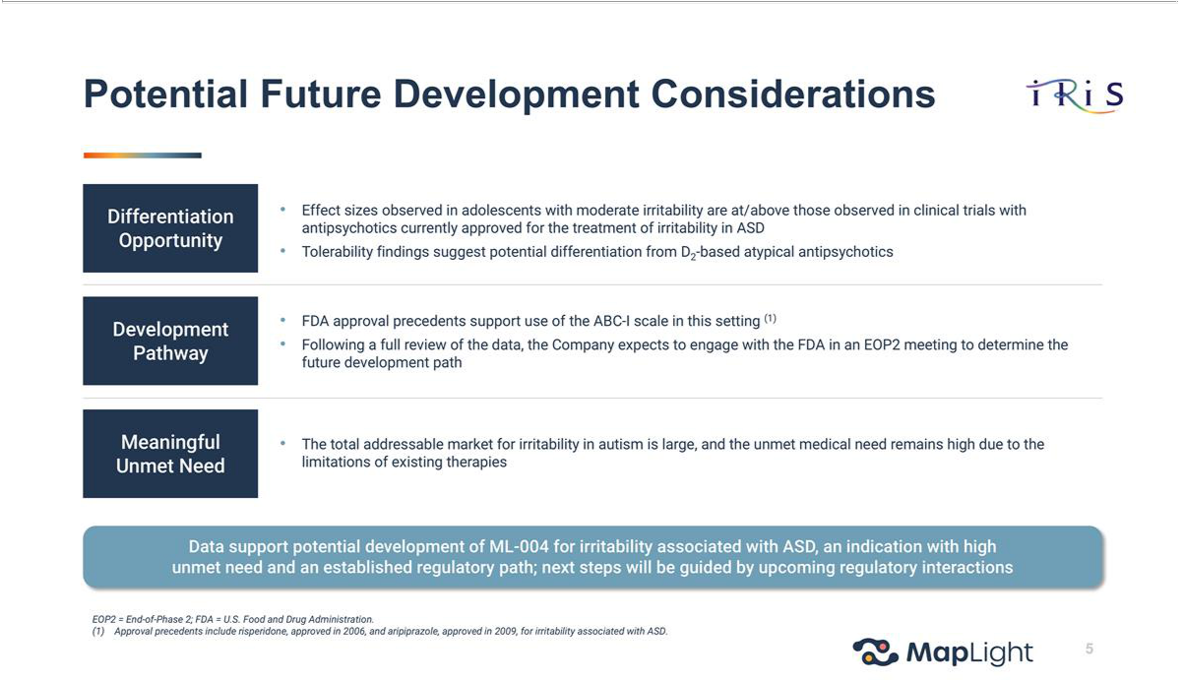

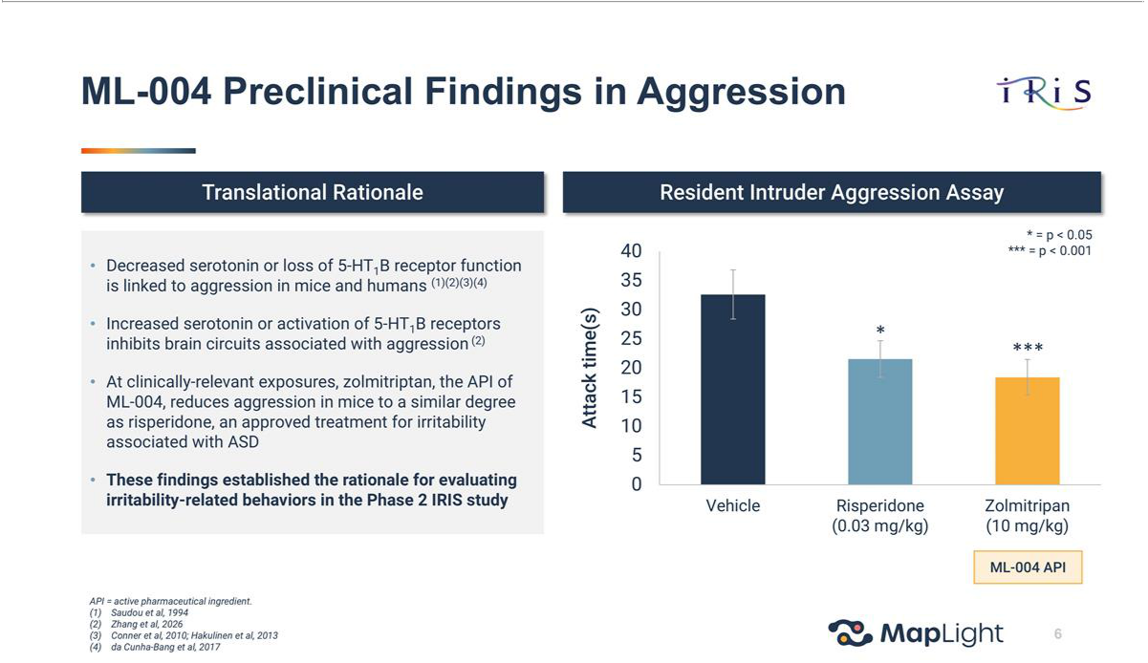



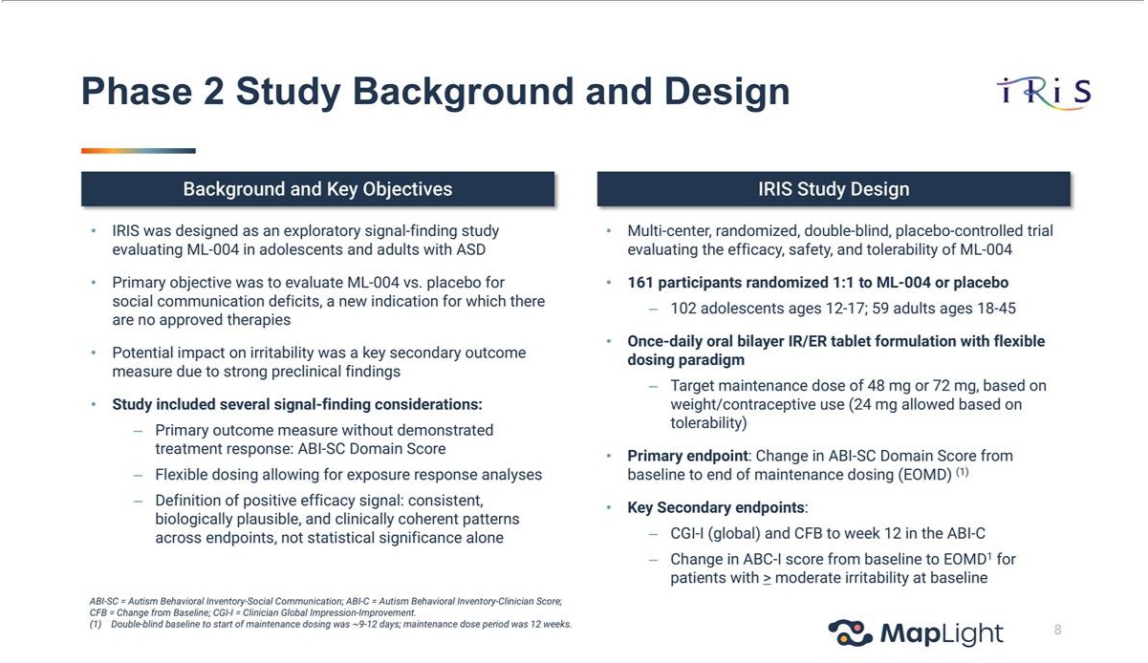

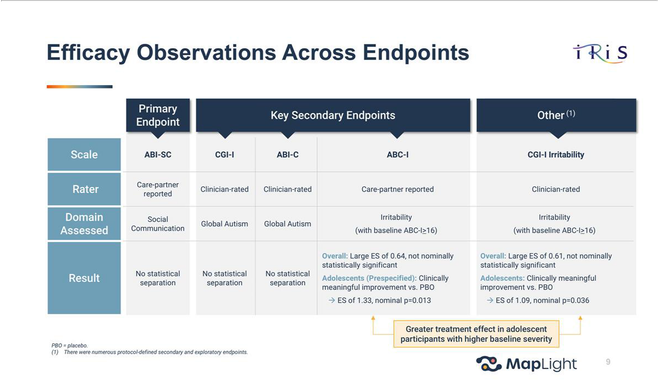

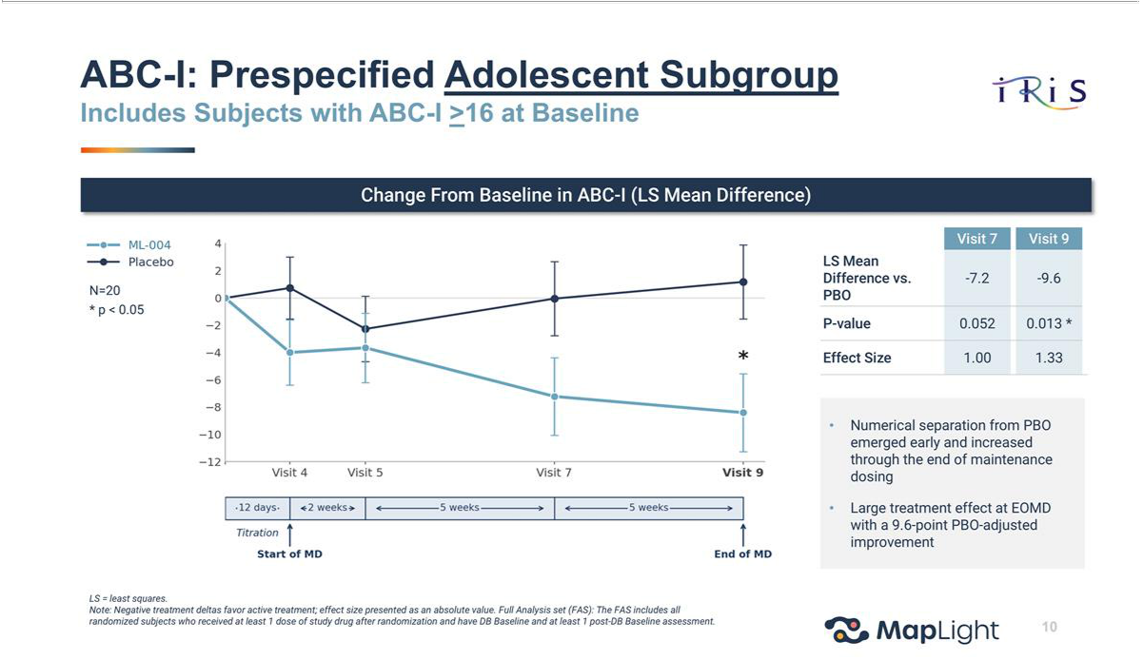

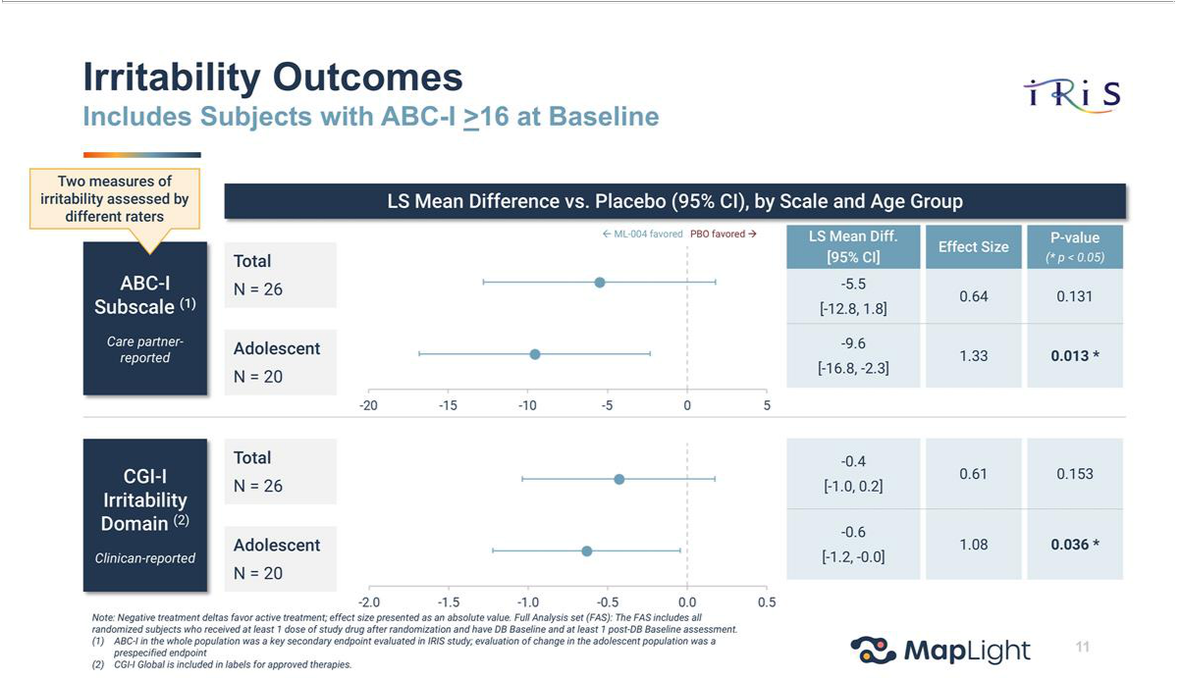

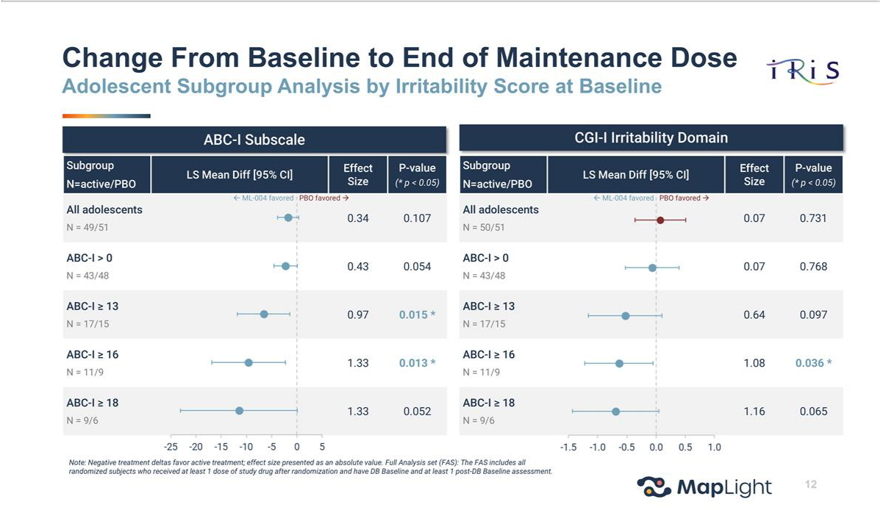

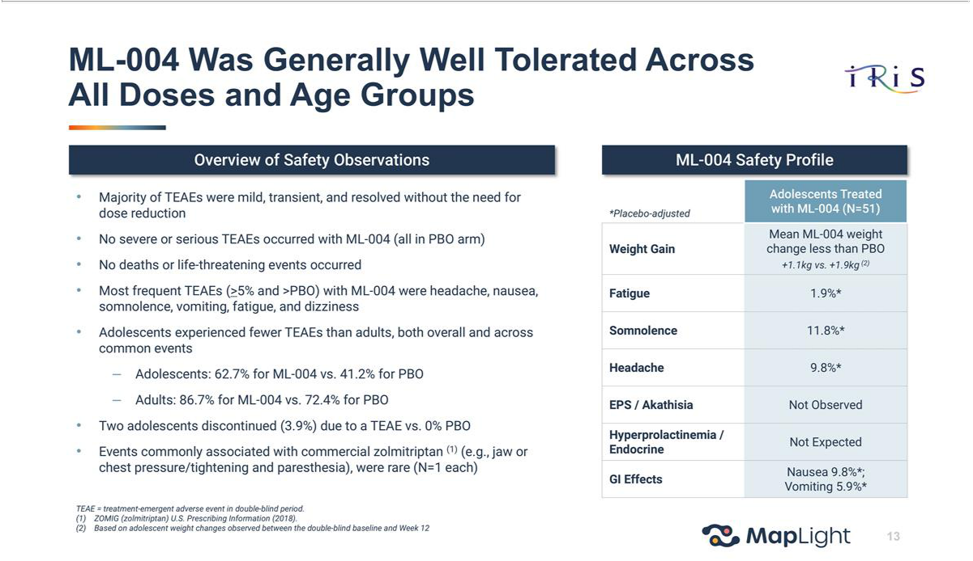

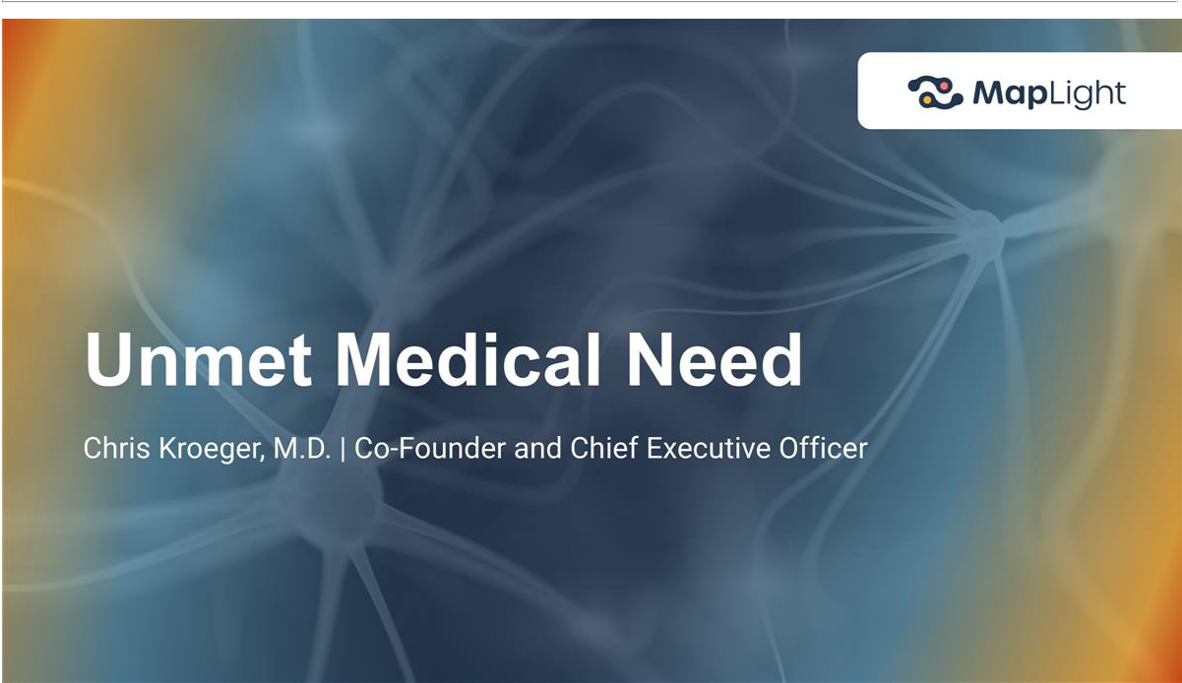

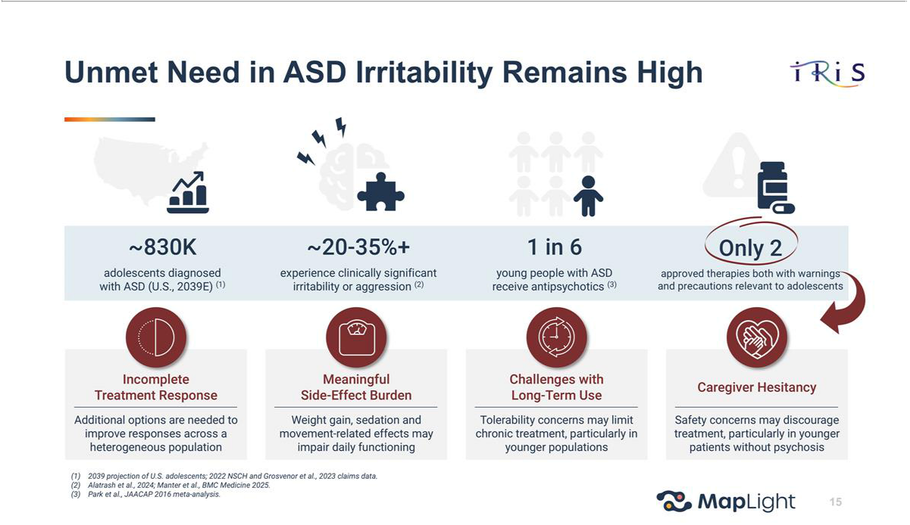

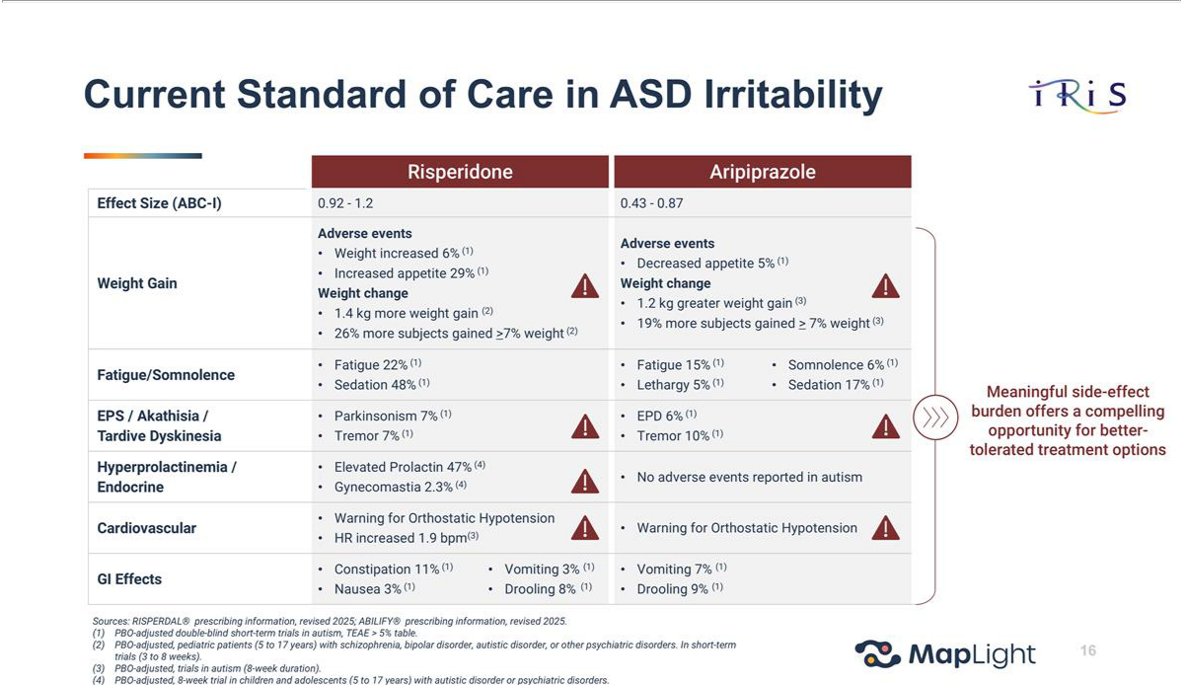

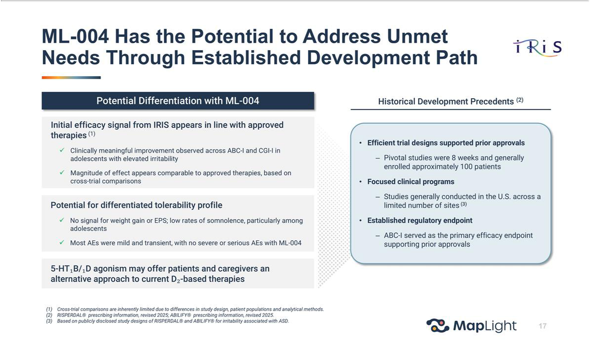

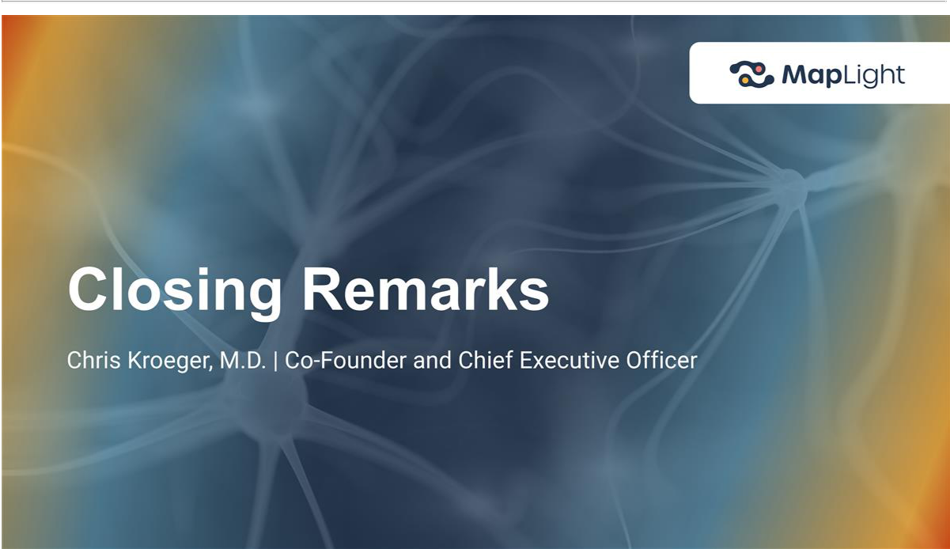

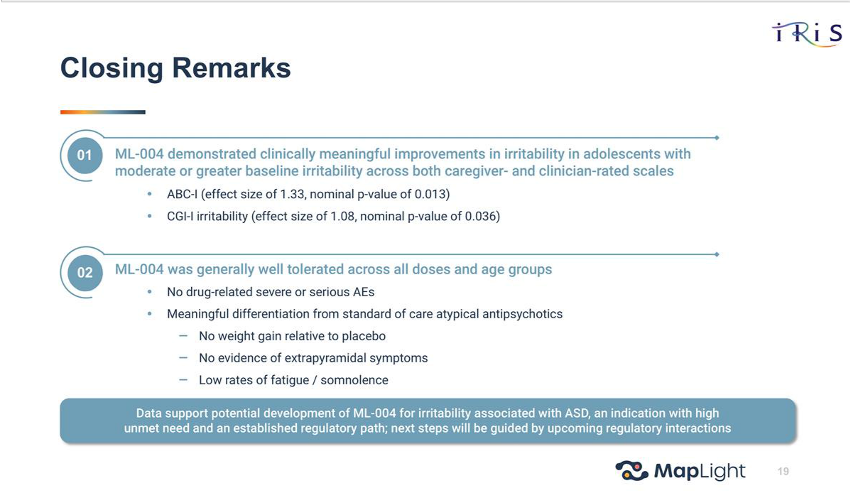

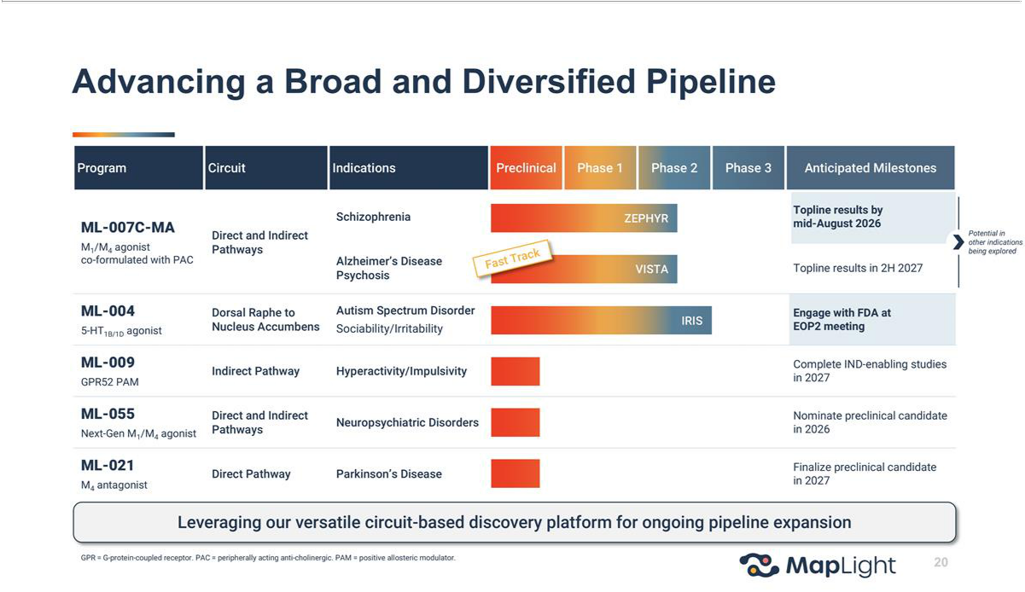

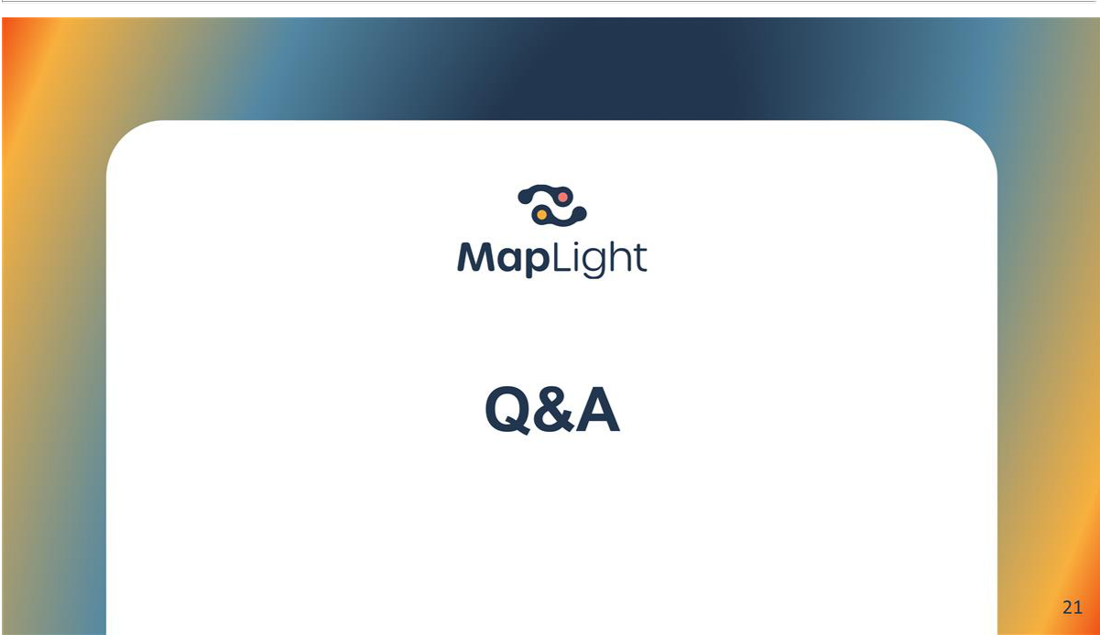

Exhibit 99.2

MapLight Announces Topline Results from Phase 2 IRIS Study for ML-004 in Autism Spectrum Disorder

- The IRIS Phase 2 trial did not meet its primary endpoint in social communication deficits associated with ASD

- A prespecified analysis in adolescents with moderate to severe baseline irritability (ABC-I ≥ 16) demonstrated meaningful improvement on the care partner-reported ABC-I over placebo (effect size 1.33, nominal p=0.013). Consistent with this, analysis of the clinician-rated CGI-I in the irritability domain for the same subpopulation demonstrated clinically meaningful improvement over placebo (effect size 1.08, nominal p=0.036). Treatment effects were greater among adolescents with greater levels of baseline irritability

- ML-004 was generally well-tolerated, with no severe or serious adverse events in the active treatment arm. No extrapyramidal events were observed, and mean weight gain was lower with ML-004 than with placebo

- Following a full review of the data, the Company expects to engage with the U.S. Food and Drug Administration (FDA) in an End-of-Phase 2 meeting to determine the clinical development path forward

- The Company remains well capitalized ahead of the topline results from its Phase 2 ZEPHYR trial evaluating ML-007C-MA in schizophrenia, expected by mid-August 2026

- Company to host live webcast today at 8:00 AM ET

SAN FRANCISCO and BOSTON, June 22, 2026 (GLOBE NEWSWIRE) — MapLight Therapeutics, Inc. (Nasdaq: MPLT), a clinical-stage biopharmaceutical company focused on improving the lives of patients suffering from debilitating central nervous system disorders, today announced topline results from IRIS (ML-004-002), a Phase 2 study of ML-004 in autism spectrum disorder (ASD). The study randomized 161 participants (102 adolescents, 59 adults), with prespecified analyses planned by age group and baseline irritability severity.

As an exploratory signal-finding Phase 2 study, IRIS was explicitly designed to test multiple clinical endpoints based on preclinical findings, including social communication and irritability, and to identify the most appropriate development path forward. The study did not meet its primary endpoint of change from baseline to Week 12 in the caregiver-reported Autism Behavioral Inventory (ABI)–Social Communication Domain score. Social communication is a domain for which no approved pharmacologic therapies exist, and for which validated, treatment-sensitive outcome measures remain an area of active scientific investigation.

However, in a prespecified analysis of adolescents (age 12–17) with moderate or greater baseline irritability (double-blind baseline ABC-I score >16, N=20), ML-004 demonstrated a clinically meaningful improvement in irritability over placebo as measured by change from baseline in the care-partner reported ABC-I subscale (LS mean difference vs. Placebo -9.58, ES=1.33, nominal p value=0.013). Consistent with this finding, clinically meaningful improvement over placebo was observed on the Clinician Global Impression-Improvement (CGI-I)-Irritability domain in the adolescent population randomized with moderate or greater baseline irritability (LS mean difference -0.63; ES=1.08, nominal p value=0.036). The treatment effects on the ABC-I and CGI-I irritability domain were more pronounced among adolescents with greater baseline irritability. In the total population of participants (age 12-45) with baseline ABC-I score >16 (N=26), ML-004 demonstrated an effect size of 0.64 (nominal p-value =0.13) on the key secondary endpoint of change from baseline in the ABC-I score at week 12.

“We are very encouraged by the robust improvements observed in adolescents with clinically significant irritability,” said Erin Pennock Foff, Chief Medical Officer. “These results are consistent with our compelling pre-clinical evidence for reduction in aggression/irritability in animal models. Given that there is an established regulatory path in this indication using the ABC-I, and given the magnitude of the effect on this measure observed in this study, we look forward to engaging with the FDA to discuss a possible path forward. We are grateful to the participants, families, and investigators whose commitment made this trial possible.”

“Irritability is a pressing clinical problem in adolescents with autism, and the only approved pharmacologic options are antipsychotics, which carry substantial metabolic and neurological burdens,” said Matthew State, M.D. Ph.D (Chair of Psychiatry and Behavioral Sciences at the University of California, San Francisco (UCSF) and member of MapLight’s Scientific Advisory Board). “An effect size of this magnitude, particularly in those most severely affected, points to a clinically meaningful improvement and warrants further investigation of ML-004 in this population.”

Safety and Tolerability

ML-004 was generally well-tolerated, with treatment-emergent adverse events (TEAEs) that were all mild to moderate in severity. Adolescents experienced fewer TEAEs than adults (Adolescent TEAEs: 62.7% for ML-004 versus 41.2% for placebo; Adult TEAEs: 86.7% for ML-004 versus 72.4% for placebo).

- There were no SAEs or severe AEs reported in the ML-004 treated participants; among placebo-treated participants, two experienced a severe TEAE and one experienced a serious adverse event

- In the randomized population, the most common TEAEs (>5% in ML-004 arm and >placebo) were headache, nausea, somnolence, vomiting, fatigue, and dizziness

- No events of extrapyramidal TEAEs were observed with active treatment. The mean weight gain over the course of the study was lower for ML-004 than placebo

- In adolescents, the most common adverse events (occurring in ≥5% of ML-004–treated adolescents and at least twice the rate of placebo) were headache (13.7% vs. 3.9%), somnolence (11.8% vs. 0%), nausea (9.8% vs. 0%), and vomiting (5.9% vs. 0%)

- Two (3.9%) adolescents in the active arm discontinued the study due to an adverse event (0% for placebo)

Live Webcast

The Company will host a live webcast to discuss the IRIS results in greater detail at 8:00 a.m. ET today, Monday, June 22, 2026. To access the live webcast, please visit the “Events and Presentations” page within the Investors section of the Maplight website https://ir.maplightrx.com/news-events/events-presentations. An archived replay will also be available on the website for at least 90 days following the event.

About ML-004 and IRIS

ML-004 is an immediate-release, or IR, and extended-release, or ER, formulation of zolmitriptan, a 5-HT1B/1D agonist currently approved for the acute treatment of migraine. The Phase 2 IRIS trial (NCT05081245) is a randomized, double-blind, placebo-controlled trial evaluating the efficacy, safety, and tolerability of ML-004 in adults (age 18-45) and adolescents (age 12-17) with autism spectrum disorder. A total of 161 participants were randomized, inclusive of 102 adolescents.

About MapLight Therapeutics

MapLight Therapeutics is a clinical-stage biopharmaceutical company focused on improving the lives of patients suffering from debilitating central nervous system disorders. The Company was founded by globally recognized leaders in psychiatry and neuroscience research to address the lack of circuit-specific pharmacotherapies available to patients. The Company’s discovery platform holds the potential to fill this void by identifying neural circuits causally linked to disease and targeting those circuits for therapeutic modulation.

For more information, please visit www.maplightrx.com.

Forward-Looking Statements

Certain statements in this press release may constitute “forward-looking statements” within the meaning of the federal securities laws, including, but not limited to, the clinical development and potential benefits of ML-004. Words such as “may,” “might,” “will,” “objective,” “intend,” “should,” “could,” “can,” “would,” “expect,” “believe,” “design,” “estimate,” “predict,” “potential,” “develop,” “plan” or the negative of these terms, and similar expressions, are intended to identify forward-looking statements. While the Company believes these forward-looking statements are reasonable, undue reliance should not be placed on any such forward-looking statements, which are based on information available to the Company on the date of this release. These forward-looking statements are based upon current estimates and assumptions and are subject to various risks and uncertainties (including, without limitation, those set forth in the

Company’s filings with the U.S. Securities and Exchange Commission (SEC)), many of which are beyond the Company’s control and subject to change. Actual results could be materially different. Risks and uncertainties include: the unpredictable relationship between preclinical study results and clinical study results; the risk that results obtained in any clinical trials to date may not be indicative of results obtained in ongoing or future trials; the timing or likelihood of regulatory filings and approvals; expectations regarding the Company’s ability to fund its current operations; and other risks and uncertainties identified in the Company’s Quarterly Report on Form 10-Q for the quarter ended March 31, 2026, and subsequent disclosure documents the Company may file with the SEC. The Company claims the protection of the safe harbor contained in the Private Securities Litigation Reform Act of 1995 for forward-looking statements. The Company expressly disclaims any obligation to update or alter any statements whether as a result of new information, future events or otherwise, except as required by law.

For investor inquiries: investors@maplightrx.com

For media inquiries: media@maplightrx.com

